CLASS Broomhead September 2021 – October 2021

SUBJECT | LEARNING
English – Stories on a theme (feeling at home)  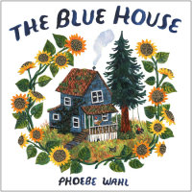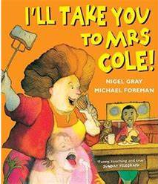 | - Explore characters and feelings  - Make predictions  - Discuss similarities and differences between texts  - Writing prepositions  - Punctuating direct speech  - Discussing, planning and writing stories based on those read
  NUMERACY | - Place Value  - Addition and Subtraction
SCIENCE – Living things and their habitats  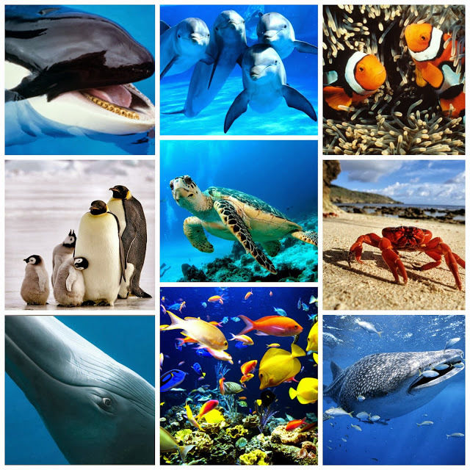 | - Learn the seven life processes (MRS NERG)  - Think about how living things can be grouped and discover that animals and plants are in different kingdoms.  - Begin to discover the mysterious world of invertebrates. Go on a bug hunt in our local environment and identify the creatures using a key.  - Create a branching tree to identify different species of fish  - Set up an investigation to find out how feathers can help birds keep a constant body temperature.  - Research the features of mammals and create a pop-up book.
Geography – Rainforests | - To learn geographical vocabulary relating to rainforests.  - To locate the rainforests and to explore the relationship of them to the Equator.  - To develop geographical vocabulary relating to rainforests and understand features of the rainforest.  - To explore the features of the rainforest in relation to the different layers
Other curriculum areas | Computing – typing and creating documents  Art – Faith Ringold collage and textiles  PSHE – Kindness and confict resolution  R.E – Who is Jesus and why is he important  P.E – weekly session with Mr Ritchie  Music – Weekly session with Beth
HOMEWORK PRIORITIES | - Reading nightly  - Bug Club  - TT Rockstars (10-15 mins)

