

Maths Long Term Plan

2023 - 2024

Reception

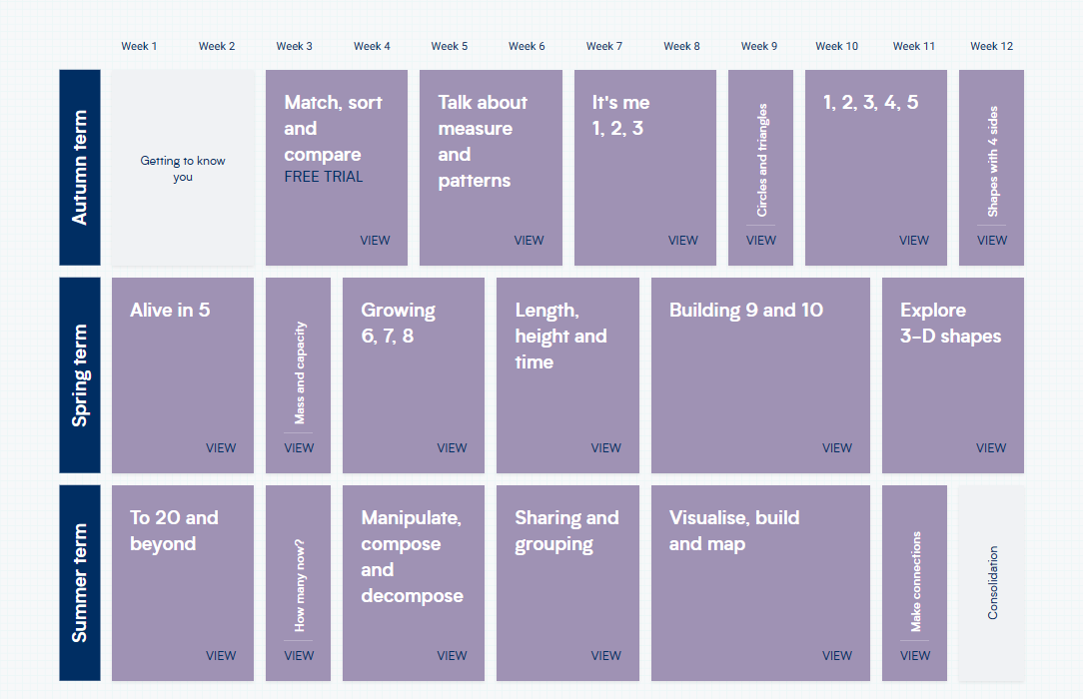

Year 1

Autumn Term 1
Place Value – within 10, 20 and 50 (4 weeks)
Addition and Subtraction (4 weeks)
Autumn 2
Addition and subtraction (4 weeks)
Money (3 weeks)

Spring Term 1
Place value (1 week)
Multiplication and Division (4 weeks)
Spring 2
Fractions (4 weeks)
Shape (2 weeks)

Summer Term
Measurement – length and height and mass and volume (3 weeks)
Time (3 weeks)
Position and direction (1 week)
Consolidation

Year 2

Autumn Term 1
Place Value (4 weeks)
Addition and Subtraction (4 weeks)
Autumn 2
Money linked with addition and subtraction (3 weeks)
Multiplication and division (3 weeks)
Shape (1 week)

Spring Term 1 (SATS)
Multiplication and Division (3 weeks)
Fractions (4 weeks)
Shape (1 week)

Summer Term
Time (2 weeks)
Statistics (2 weeks)
Measurement – length and height and mass and volume (2 weeks)
Position and direction (1 week)

Year 3
Times tables lesson each week recorded in a separate book

Autumn Term 1
Place Value (4 weeks)
Addition and Subtraction (4 weeks)
Autumn 2
Money link with addition and subtraction (3 weeks)
Multiplication and Division (5 weeks)

Spring Term
Fractions (4 weeks)
Shape (recap 2D and 3D shapes then angles) (2 weeks)
Spring 2
Length and perimeter (3 weeks)
Measurement – (mass, capacity and temperature) (3 weeks)

Summer Term
Time (2 weeks)
Statistics (2 weeks)
Position and direction (1 week)
Consolidation

Year 4
Times tables lesson each week recorded in a separate book

Autumn 1 Term
Place Value (4 weeks)
Addition and Subtraction (4 weeks)
Autumn 2
Multiplication and Division (4 weeks)
Fractions (4 weeks)

Spring Term 1
Fraction and decimals (4 weeks)
Length, perimeter and area (3 weeks)
Spring Term 2 (Times tables test)
Money linked to addition and subtraction
Length, perimeter and area (3 weeks)

Summer Term
Time
Statistics (2 weeks)
Position and direction (1 week)
Consolidation

Year 5
Times tables lesson each week recorded in a separate book

Autumn Term 1
Place Value and negative numbers (3 weeks)
Addition and Subtraction (4 weeks)
Autumn Term 2
Multiplication and Division (4 weeks)
Fractions A (4 weeks)

Spring Term 1
Fractions B ( 2 weeks if needed)
Decimals and percentages (3 weeks)
Spring term 2
Perimeter and area (3 weeks)
Statistics (2 weeks)

Summer Term
Shape
Position and direction (1 week)
Converting units – measures and volume
Consolidation

Year 6
Times tables lesson each week recorded in a separate book

Autumn Term 1
Place Value (4 weeks)
Addition/Subtraction (4 weeks)
Autumn 2
]Multiplication/Division (3 weeks)
Fractions A (2 weeks) Fractions B (3 weeks)
Fractions, decimals and percentages (4 weeks)

Spring Term 1 (SATS) Revision sessions – basic skills taught once a week
Area, perimeter and length (2 weeks)
Algebra (2 weeks)
Shape (2 weeks)
Converting units

Summer Term
Ratio
Time
Position and direction

