
Class Plans
CLASS: Pearce Term: Summer 1
SUBJECT | LEARNING
LITERACY  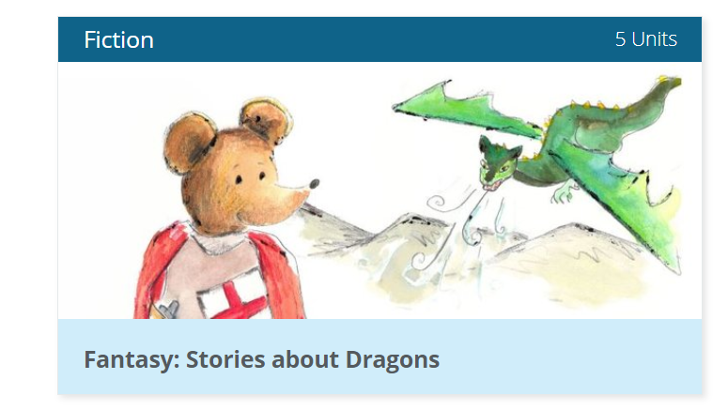 | Fiction – Adventure Stories  Dragons are ancient and fascinating mythical creatures. Read, sequence, compare and review dragon stories, produce a version of Paper Bag Princess. Use noun phrases and conjunctions.
MATHEMATICS  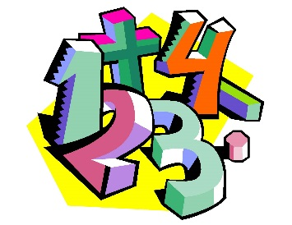 | Fractions – understanding unit fractions  Numerators and denominators  Equivalent fractions  Ordering fractions
Times Tables
Tames tables lessons take place once each week. We learn through a variety of fun and engaging activities.
SCIENCE | Electricity  - I can identify common appliances that run on electricity  - • I can construct a simple series electrical circuit,  - switches and buzzers  - • I can identify whether or not a lamp will light in a simple series circuit,  - complete loop with a battery  - • I can recognise that a switch opens and closes a circuit  - series circuit  - • I can recognise some common conductors and insulators,
OTHER TOPICS | History – Crime and Punishment  Music - with Beth from Trafford Music Service on Thursday  PE –Agility balance and co-ordinationon on a Friday with Mr Richie, Play to Learn on a Monday  RE – Life as a Journey / Significant experiences
SPECIAL EVENTS/HOLIDAYS   | Please keep up-to-date with letters and our web page where you find all our special events oraganised!  - Please refer to our school calender 2022-2023 reminders to follow as and when they occur.
HOMEWORK PRIORITIES   | There is no official homework that is set by class but please make sure to work with your child on:  - Maths: Practice times tables. All children have Times Table Rockstars logins and set times tables.  - English: Work on spellings from their reading books.  - Reading: Please read the book you take home every evening

INDIVIDUAL BEHAVIOUR TARGETS
Please refer to your child’s IEP and get in touch with the class teacher if you have any concerns.
....................................................................................................................................................


