
Class Plan
Class: Lamb Term: Summer 2024
SUBJECT | LEARNING
LITERACY  SATS SPAG  SATS reading | Biographies - Mathematicians  Inspire your class with the incredible stories of marvellous mathematicians: Katherine Johnson, Dorothy Vaughn, Paul Erdos and Albert Einstein, among others. Study the features of biographies, write persuasively to 'sell' an idea for a biopic and learn how to use adverbials to link ideas across paragraphs.  Reading comprehensions
MATHS  SATS revision  Times tables practice once a week. | Group 1  Fractions and decimals  Percentages  Arithmetic  SATS revision  Group 2  Fractions and decimals  Percentages  Statistics  Group 3  Fractions and decimals  Money  Statistics
SCIENCE  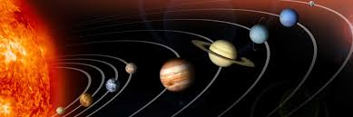  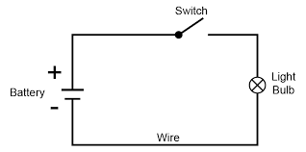 | Year 5  Space  Describe the movement of the Earth and other planets, relative to the sun in the solar system.  Describe the movement of the moon relative to the Earth.  Describe the Sun, Earth and Moon as approximate spherical bodies.  Use Earth rotation to explain day and night due to the apparent movement of the sun across the sky.  Animals Including Humans  Describe the changes as humans develop from birth to old age.  Year 6  Electricity  To compare and give reasons for variations in how components function, including the brightness of bulbs, the loudness of buzzers and the on/off position of switches.  To associate the brightness of a lamp or the volume of a buzzer with the number and voltage of cells used in the circuit.  To use recognised symbols when representing a simple circuit in a diagram.
History  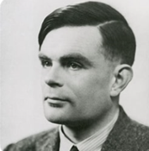 | Who was Alan Turing?  What was the impact of Allan Turning on the war?  Why did WW2 start?  What were the main events in WW2?  What was the Home Front and why was it important?
Computing: Data handling – Big Data 1

RE: U2.7 What matters most to Christians and Humanists?
Strand: Believing

Art: Archibald Leitch
Exploring and Developing Ideas, Work of Artists,
Drawing shadows and perspective with a range of media
Sculpture use tools to carve shape/texture/pattern using materials other than clay (eg wire, foil, modroc)
PSHE:
Exercise and hygiene
Looking after myself
the benefits of physical exercise, time outdoors, community participation, voluntary and service-based activity on mental wellbeing and happiness

PE: Striking and Fielding Games
NC: Use running, jumping, throwing and catching in isolation and in combination.
Play competitive games, modified where appropriate (cricket and rounders).
Take part in outdoor and adventurous activity challenges both individually and within a team.

Mr Ritchie on a Tuesday and Play to Learn on a Wednesday.

Music with Beth on a Thursday.

French with Specialist on a Tuesday.

SPECIAL EVENTS/  HOLIDAYS  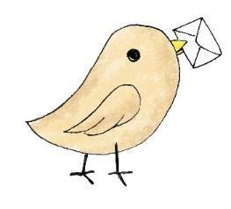 | Please keep up-to-date with letters and our web page where you find all our special events organised!  - Please refer to our school calendar 2023-2024 – reminders to follow as and when they occur.  Year 6 SATS 13th – 17th May 2024
READING   | We read every day in school.  Your child will be taking a reading book home to read with an adult. Please try and read a few pages with your child and record it in their reading record.

