
Class Plans
Class: Poonia Term: Summer 1
SUBJECT | LEARNING
LITERACY  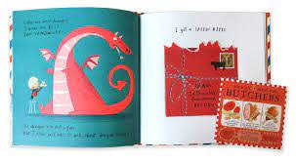 | We will be reading the book ‘Dragon Post,’ and finding out about all types of letters.  We will be considering each other’s points of view and discussing words and phrases that capture our interest and imagination. The pupils will be asking questions to improve their understanding.
MATHEMATICS  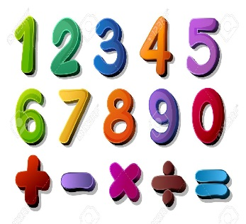 | SATS  We will be starting Arithmetic practice and then slowly moving to reasoning and problem-solving so that children can build their confidence.  Fractions  One group will be adding fractions and then moving onto decimals. | Mass and Capacity  Another group will be learning about Mass and Capacity.  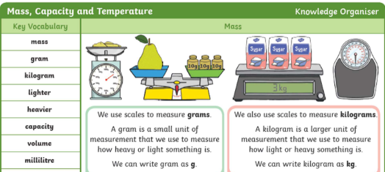
SCIENCE   | Living things and habitats
OTHER TOPICS    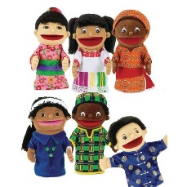 | History-  We will be looking at life before and after Queen Victoria.  RE-  We are.  French-  Every Tuesday with our teacher who has been looking at colours, animals and greetings.  Music-  Every Thursday we have Music with Beth from Trafford Music Service.  PE- with Mr Ritchie on Thursday  DT-  Art-  PSHE- How to keep our bodies healthy.
SPECIAL EVENTS/HOLIDAYS   | Please keep up-to-date with letters and our web page where you find all our special events organised!  - Please refer to our school calendar 2023-2024 – reminders to follow as and when they occur.
READING   | We read every day in school and if possible, we would like you to read with your child each night.

INDIVIDUAL BEHAVIOUR TARGETS
Please refer to your child’s IBP and get in touch with the class teacher if you have any concerns.
...................................................................................................................................................

