
Class Plan
Class: Tan Term: Summer 1 2024
SUBJECT | LEARNING
LITERACY  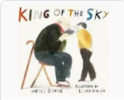  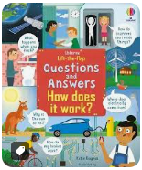 | We will start the term by continuing our work on the book ‘King of The Sky’. We have been reading books with similar themes and have been learning all about birds.  We will then be using the book ‘How does It Work?’ by Katie Daynes to help us write instructions and explanations. We will build on our previous work on conjunctions then we will look at adverbs to order and specify.  We will write instructions for robots and an instruction leaflet on a specialist subject.
MATHS  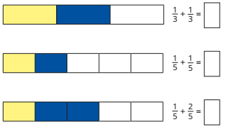  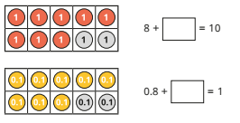 | Some children will be finishing off their work on capacity before moving back to extend their knowledge and understanding of fractions. This will involve adding and subtracting fractions and finding fractions of an amount.  We will then do some work on money and will practise pounds and pence, adding and subtracting money and finding change.  Other children will be continuing their work on tenths and hundredths. They will then apply this learning to money and will learn to estimate, compare and calculate with money. Finally, we will move onto time where we will be using both the 12 and 24 hour clock.
SCIENCE   | Electricity  We will learn to:  - Identify common appliances that run on electricity  - Construct a simple series electrical circuit, identifying and naming its basic parts, including cells, wires, bulbs, switches and buzzers  - Identify whether or not a lamp will light in a simple series circuit, based on whether or not the lamp is part of a complete loop with a battery  - Recognise that a switch opens and closes a circuit and associate this with whether or not a lamp lights in a simple series circuit  - Recognise some common conductors and insulators, and associate metals with being good conductors.  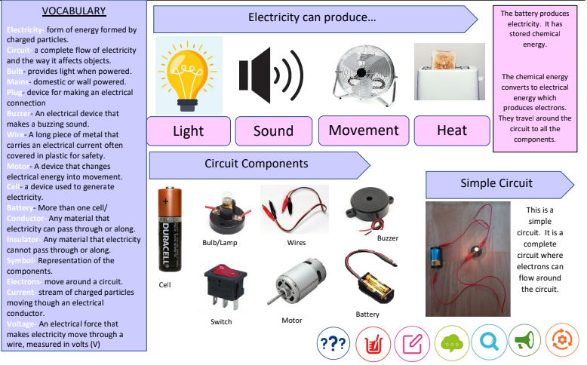
History | 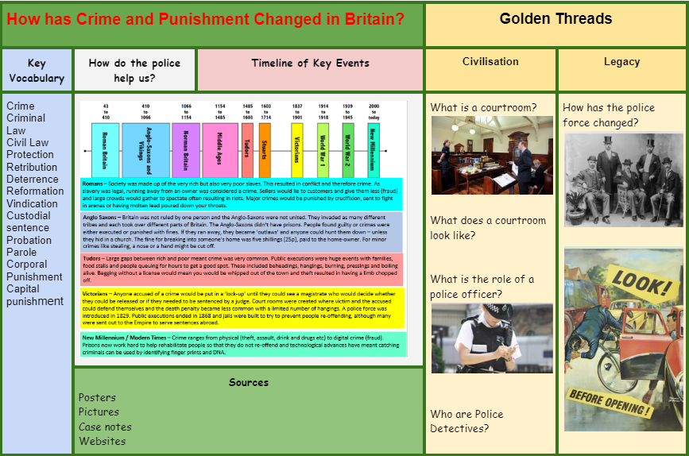
SPECIAL EVENTS/HOLIDAYS  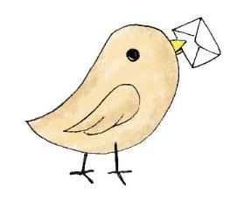 | Please keep up-to-date with letters and our web page where you find all our special events organised!  - Please refer to our school calendar 2023-2024 – reminders to follow as and when they occur.
READING   | We read every day in school.  Your child will taking a reading book home to read with an adult. Please try and read a few pages with your child and record it in their reading record.

