
Class Plans
Class: Poonia Term: Spring 1
SUBJECT | LEARNING
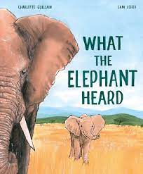  LITERACY  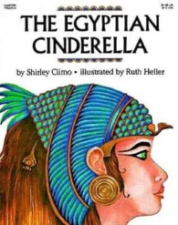 | We have started the Spring Term, with a book about change called ‘What the Elephant Heard.’ This fits in well with the change the class have gone through and looks at the resilience of Elephants. The class will be exposed to new vocabulary and will look at synonyms and antonyms.  After a week, we will be looking at Non-Fictions Texts about Ancient Egypt and reading and discussing the book, ‘The Egyptian Cinderella.’ We will be creating our own short story before half term.
MATHEMATICS  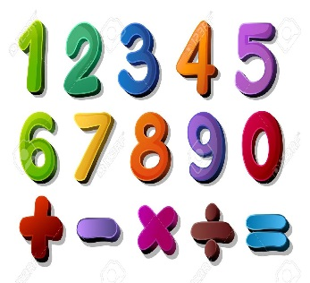 | Spring 1  Multiplication and division  We will be learning about multiplying and dividing 2 digits by 1-digit numbers. Also, factors, multiplying 3 digits by 2-digit numbers and problem-solving.  Fractions  One group will be accessing Fraction learning. | Timetables  Class Poonia will be practising their timetables once a week, as well as access to reasoning and problem-solving word problems.
SCIENCE   | Spring 1  Space  In Year 5, we will be describing the movement of the Earth and other planets, the moon, sun as spherical bodies. We will learn about the Earth’s rotation to explain night and day. | Electricity  Another group will be learning about Electricity, associating the brightness of a lamp or the volume of a buzzer with the number of voltage of cells used in a circuit. As well as recognising symbols when representing a simple circuit in a diagram.
OTHER TOPICS    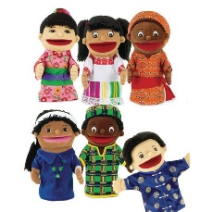 | History-  We will be looking at the achievements of Ancient Egypt and taking part in an in-depth study of the early civilisation.  RE-  We are looking at the Muslims in Britian.  French-  Every Tuesday with our teacher who comes from France.  Music-  Every Thursday we have Music with Beth from Trafford Music Service.  PE- with Mr Ritchie on Thursday  DT- Mosaics  Art- Henry Moore  PSHE- How to stay safe.
SPECIAL EVENTS/HOLIDAYS   | Please keep up-to-date with letters and our web page where you find all our special events organised!  - Please refer to our school calendar 2023-2024 – reminders to follow as and when they occur.
READING   | We read every day in school and if possible, we would like you to read with your child each night.

INDIVIDUAL BEHAVIOUR TARGETS
Please refer to your child’s IBP and get in touch with the class teacher if you have any concerns.
...................................................................................................................................................

