
Class Plan
Class: Tan Term: Spring 1 2024
SUBJECT | LEARNING
LITERACY | This half term, we are starting off by finishing his work on Festival Poetry.  Harry Potter Report Writing  The children have been enjoying reading Harry Potter as our class book.  We are going to use this text for a unit about report writing this half term. We will read reports about Harry Potter studio tours.  We will look at features of reports; study conjunctions and prepositions and adverbs.  We will also look at Hogwarts students’ school reports and have a go at writing our own.
MATHS  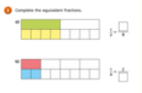  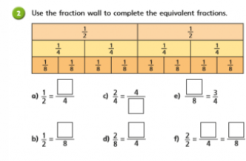 | Multiplication  We are finishing our work on multiplication and division but will continue to work on our times tables.  Fractions.  Recap what a fraction is and what the different parts of a fraction represent as well as representing fractions in different ways.  Understand that finding a fraction of an amount relates to division  Recognise, find and write fractions of a discrete set of objects: unit fractions and non-unit fractions with small denominators  Recognise and use fractions as numbers: unit fractions and non-unit fractions with small denominators  Recognise and show, using diagrams, equivalent fractions with small denominators  Compare and order unit fractions, and fractions with the same denominators (including on a number line)  Count on and back in steps of unit fractions  Recognise and write decimal equivalents of any number of tenths or hundredths  Add and subtract fractions with the same denominator (using diagrams)
SCIENCE  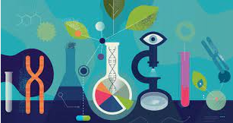 | States of Matter  In Science, we will be learning about the different states of matter.  We will:  - Compare and group materials together, according to whether they are solids, liquids or gases.  - Observe that some materials change state when they are heated or cooled, and measure or research the temperature at which this happens in degrees Celsius  - Identify the part played by evaporation and condensation in the water cycle and associate the rate of evaporation with temperature.  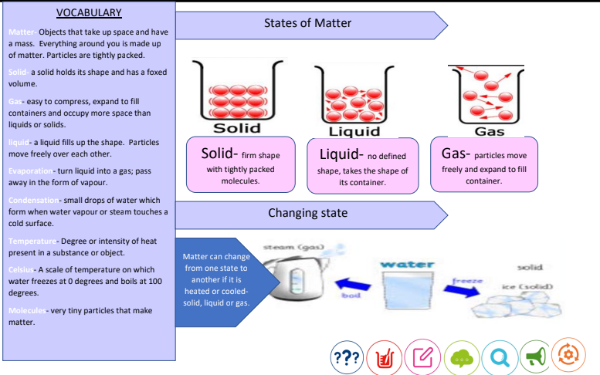
History | 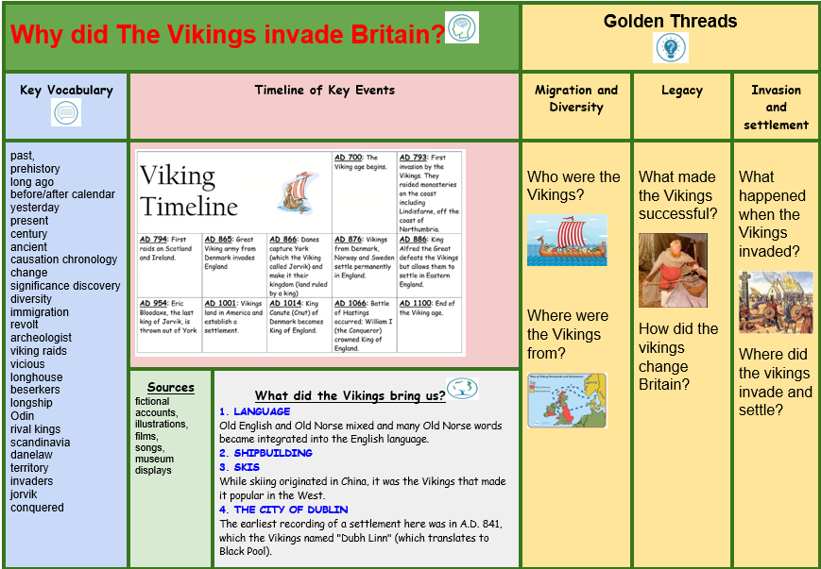
SPECIAL EVENTS/HOLIDAYS  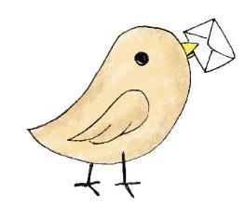 | Please keep up-to-date with letters and our web page where you find all our special events organised!  - Please refer to our school calendar 2022-2023 – reminders to follow as and when they occur.
READING   | We read every day in school.  Your child will taking a reading book home to read with an adult. Please try and read a few pages with your child and record it in their reading record.

