
Class Plan
Class: Newiss Term: Autumn 1 2023
SUBJECT | LEARNING
LITERACY  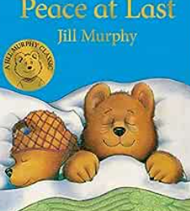  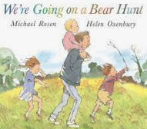  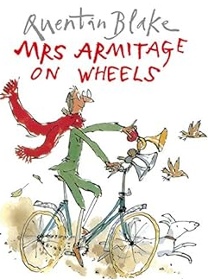 | Phonics will be taught daily following the Little Wandle programme. Your child will be assessed in September to ensure sessions accurately reflect their ability and current knowledge. Phase 2 and Phase 3 sounds will be covered.  Guided Reading sessions will focus on; Decoding, Fluency and Comprehension.  Daily Shared Reading sessions of a variety of books linked to our English, Science and History topics.  We will begin to learn about the 5 key concepts of print. Use our exciting books to talk about stories and learn new vocabulary. Continue to practise our lowercase letter formation. Continue to practise writing our names. Begin to compose simple phrases and imaginary sentences.  In English, we will look at the following units:  Families and Me – labels and captions  Repetition in stories – repeating patterns
MATHS | Reception  Match, Sort and Compare  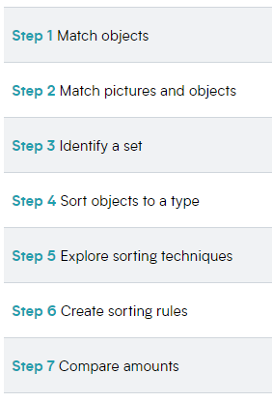  Talk about measure and patterns  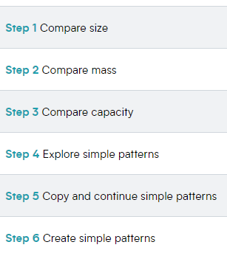  It’s me 1,2,3  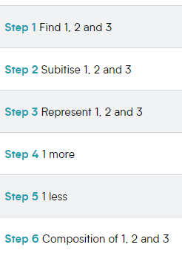 | Year 1  Place Value  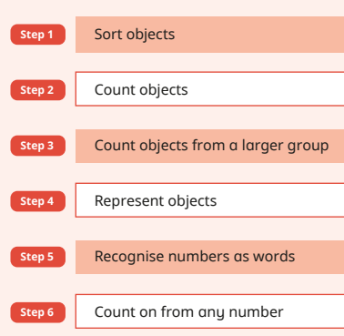  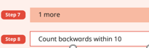  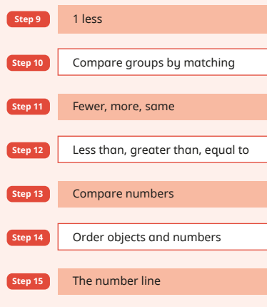  Some steps will be covered over several lessons.
Science    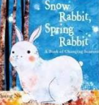 | Reception  Understanding the World  Begin to understand the need to respect and care for the natural environment  The Natural World  Explore the natural world, making observations.  Understand some important processes and changes in the natural world, including the seasons. | Year 1  Seasonal Changes  Observe changes over the seasons.  Observe and describe weather associated with the seasons and how day length varies.
History    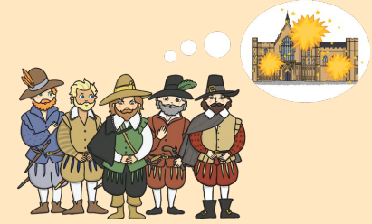 | Reception  Celebrations  Understanding the World  Compare and contrast characters from stories including figures from the past  Past and Present  Know some similarities and differences between things in the past and now, drawing on their experiences and what has been read in class. | Year 1  Why do we remember 5th November?  Through historical enquiry we will ask and begin to look at questions about the Gunpowder Plot such as;  What happened on 5th November?  What was it like in 1605?  Why did Guy Fawkes want to blow up Parliament?  Who was involved?  Who were Guy Fawkes and James I?
Computing | Opportunities to develop computing skills by continuous provision. | Computing systems and networks  Learning how to log in and navigate around a computer, developing mouse skills, learning how to drag, drop, click and control a cursor to create works of art.  Using Sketchpad.
RE  LPS follows the Manchester Agreed Syllabus 2022 - 2027 | Reception  Believing Strand  Which stories are special and why?  What is your favourite story?  What do you like about it and why? | Year 1  Believing Strand  Who is a Christian and what do they believe?
Art  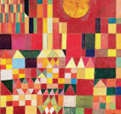 | Expressive Arts and Design  Explore colour and colour mixing.  Creating with materials  Safely use a variety of materials, tools and techniques experimenting with colour, design, texture, form and function. | Paul Klee  Develop carving skills to create a print in the style of Paul Klee.
PE | Wednesday and Friday with Mr Ritchie  Physical development and Gross motor Skills.
PSHE | Reception  Families and Relationships  Safe Relationships  Respecting ourselves and others | Year 1  Families and Relationships  Safe Relationships  Respecting ourselves and others
SPECIAL EVENTS/  HOLIDAYS  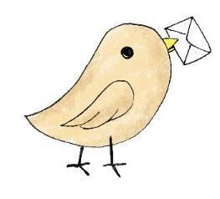 | Please keep up-to-date with letters and our web page where you find all our special events organised!  - Please refer to our school calendar 2023-2024 – reminders to follow as and when they occur.
READING   | We read every day in school.  Your child will be taking a reading book home to read for pleasure with an adult. Please try and read a few pages with your child and record it in their reading record. Your child will have access to the Collins e book library where a book will be set for them with will be closely linked to their phonic ability.

