
Class Plan
Class: Tan Term: Autumn 1 2023
SUBJECT | LEARNING
LITERACY  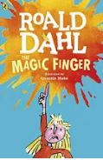 | This term we will be following the story of The Magic Finger.  We will be thinking about the characters and talking about persuasive language. We will look at some adverts to help us with this.  We will be learning to use question marks, different tenses and conjunctions.
MATHS  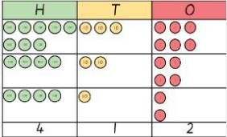 | We will start off the half term by ensuring a good understanding of number and place value. We will use various models and images to support us with our learning. These will include place value charts, place value counters and base ten.  We will use our understanding of number and place value to help us understand our addition and subtraction.
SCIENCE  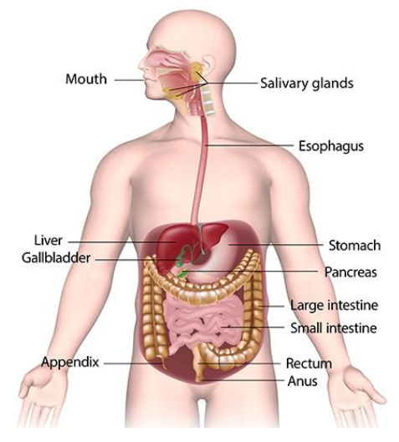 | Animals Including Humans  We will learn to describe the simple functions of the digestive system in humans, identify different teeth in humans and name their functions, know how to keep our teeth healthy and identify and compare teeth of carnivores, herbivores and omnivores. We will construct and interpret a variety of food chains identifying producers, predators and prey by examining animal faeces. and identify animal habitats in the locality and observe what they eat
History  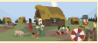 | In History we will be learning about the Anglo-Saxons, Scots and Picts. We will be answering questions such as:  What was the myth of Hengest and Horsa?  What was the difference between The Scots and The Picts?  Where did The Anglo-Saxons settle?  Why did The Anglo Saxons come to Britain?  Why did the Romans invite The Saxons to Britain?  RE – What does it mean to be a Hindu in Britain today?  Music - Trafford Music Service on a Thursday.  Computing – E-safety, Computing systems and networks and Collaborative learning.  PE – taught by Mr Ritchie on a Monday and Tuesday– Please have PE kits in school.
SPECIAL EVENTS/  HOLIDAYS  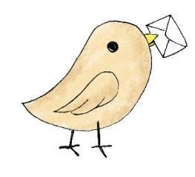 | Please keep up-to-date with letters and our web page where you find all our special events organised!  - Please refer to our school calendar 2023-2024 – reminders to follow as and when they occur.
READING   | We read every day in school.  Your child will taking a reading book home to read with an adult. Please try and read a few pages with your child and record it in their reading record.

