
Class Plan
Class: Lamb Term: Autumn 1 2023
SUBJECT | LEARNING
LITERACY  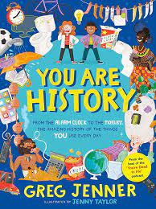 | Reports  Non-Fiction: Reports: You are History!  Investigate expanded noun phrases and fronted adverbials. Write reports for a new book, We are History.  Spellings
MATHS  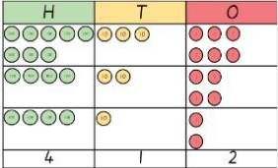  Times tables practice once a week. | Place value  Group 1 Group 2  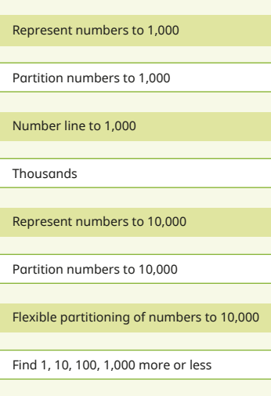  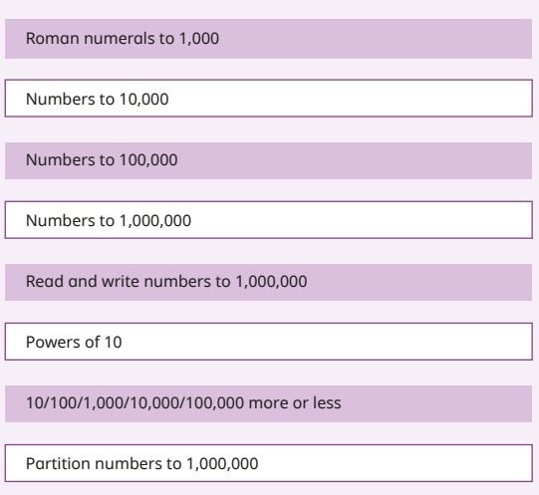
SCIENCE  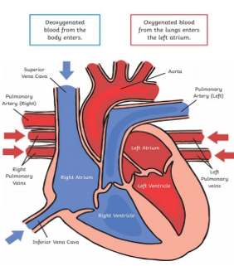 | Year 5  Animals Including Humans  Describe the changes as humans develop from birth to old age.  Ask relevant questions.  Make careful observations and use a range of equipment.  Gather, record and classify data.  Record findings using scientific language, drawings, labelled diagrams.  Identify similarities and differences.  Use straightforward scientific evidence to answer questions to support findings.  Animals Including Humans  Year 6  Identify the main parts of the human circulatory system and describe the function of the heart, blood vessels and blood.  Describe the ways in which nutrients and water and transported within animals including humans.  Recognise the impact of diet, exercise, drugs and lifestyle on the way their bodies function.
History  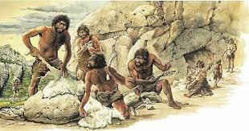 | What is Pre-History?  ➢ What was the chronology of the pre-historic period?  ➢ How do historians discover what happened in the past?  ➢ What is the legacy of the prehistoric period?  ➢ What was prehistoric Manchester like?  Computing: E-safety & Computing Systems/Networks  RE: Is it better to express your beliefs in arts and architecture or in charity and generosity?  PSHE: Mental Health and Wellbeing What is a respectful relationship? Discussion around what is a safe relationship  PE with Mr Ritchie on a Tuesday. Swimming on Friday afternoons.  Music with Beth on a Thursday.  French with Specialist  RE – What does it mean to be a Hindu in Britain today?  Music - Trafford Music Service on a Thursday.  Computing – E-safety, Computing systems and networks and Collaborative learning.  PE – taught by Mr Ritchie on a Monday and Tuesday– Please have PE kits in school.
SPECIAL EVENTS/  HOLIDAYS  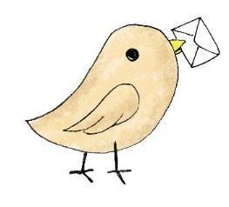 | Please keep up-to-date with letters and our web page where you find all our special events organised!  - Please refer to our school calendar 2023-2024 – reminders to follow as and when they occur.
READING   | We read every day in school.  Your child will be taking a reading book home to read with an adult. Please try and read a few pages with your child and record it in their reading record.

