
Class Plans
Class: Shafai Term: Autumn one 2023
SUBJECT | LEARNING
LITERACY  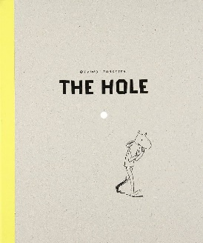 | Our book for this Autumn term is The Hole by Oyvind Torseter. This book looks at themes of exploration and asking for help when you need it. It will also give us an opportunity to predict future events in the book and writing our own version of the hole.  We will also be focusing on punctuation and grammar and doing spelling lessons three times a week to help us to improve our spelling and widen our vocabulary and word bank
MATHEMATICS  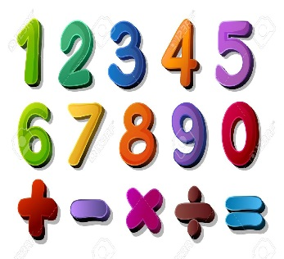 | Autumn one  Place Value  We will be learning about the value of each digit in any given number up to and including the hundreds of thousands  Addition and Subtraction  We will be learning about column addition and column subtraction | Alongside our topics in Maths, we will also be focusing on our times tables once a week so that we can start to become fluent in them.
SCIENCE  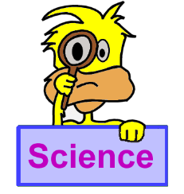 | Autumn one  Animals including humans:  We will be looking at the digestive system, teeth, life cycles and the changes in humans as we get older | We will think about our topic and come up with enquiry questions and find out the answers to our questions!
OTHER TOPICS  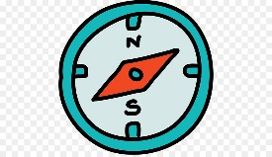  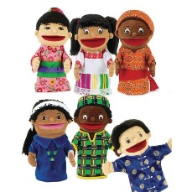 | History: The history of Benin  RE – We are looking at why we need places of worship if God is everywhere  French- Every Tuesday with our teacher who comes from France  Music - with Beth from Trafford Music Service on Thursday.  PE – with Mr Ritchie on Thursday  DT: Cooking  Art: Van Gogh
SPECIAL EVENTS/HOLIDAYS   | Please keep up-to-date with letters and our web page where you find all our special events organised!  - Please refer to our school calendar 2023-2024 – reminders to follow as and when they occur.
READING   | We read every day in school and if possible, we would like you to read with your child each night.

INDIVIDUAL BEHAVIOUR TARGETS
Please refer to your child’s IBP and get in touch with the class teacher if you have any concerns.
...................................................................................................................................................

