Class Broomhead September 2023 – October 2023

SUBJECT | LEARNING
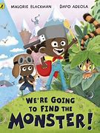  English – We’re Going to Find a Monster by Malorie Blackman and Dapo Adeola | - Using descriptive language  - Writing in sentences  - Rhyming words  - Reading poems  - Inventing a new character  - Writing a poem about this character
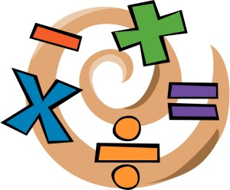  NUMERACY | - Place Value  - Reading and writing numbers  - Ordering numbers  - Addition
SCIENCE –  Y3 – Rocks  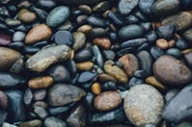 | • Compare and group together different kinds of rocks on the basis of their appearance and simple physical properties  • Describe in simple terms how fossils are formed when things that have lived are trapped within rock  • Recognise that soils are made from rocks and organic matter
History - Ancient Greece  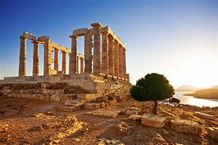 | - What do the first civilisations have in common?  - What was the Greek Empire?  - How did the Ancient Greeks trade?  - How did the Ancient Greeks live?  - What is democracy?  - What sports did the Ancient Greeks do?
Other curriculum areas | Computing – E-safety, Computing systems and networks  Art – Self portraits and Sculpture  PSHE – Families and relationships  R.E – What does it mean to be a Christian in Britain today?  P.E – weekly session with Mr Ritchie  Music – Weekly session with Beth
At Home | - Reading nightly

