
Class Plans
CLASS: Patel Term: Autumn Term 1
SUBJECT | LEARNING
LITERACY  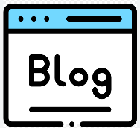 | Looking at website texts, revisit features of informal/formal writing including subjunctive mood, active/passive and question tags. Compose 'About Me' profiles and blog posts.  Establish cross-curriculur links, especially ICT as we will incorporate our information texts into some Game cases.  In conjunction, we will further strengthen our proper use of spelling, grammar and punctuation in our writing.
MATHEMATICS   | Group 1  Place value - 4 weeks  Addition and subtraction – 4 weeks | Group 2  Place value and negative numbers – 3 week  Addition and subtraction – 5 weeks
Group 3
Place Value – 2 weeks
Addition and subtraction – 6 weeks
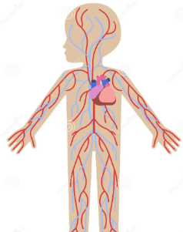  SCIENCE | Living things and their habitats  - The Skeletal system  - The Circulatory system  - The Blood  - Nutrients and transport  - Foods and benefits  - Effects of Smoking
OTHER TOPICS  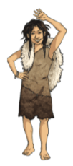 | What is Pre-History  This terms topic is What is Pre-history taught by Mr Roberts. We will look into what life was like before history was recorded and the differences in our communities now and then.  We hope to carry out some fieldwork into our own community to help us with our understanding of our own area.  Music - with Beth from Trafford Music Service on Thursday.  PE –Athletics with Mr Ritchie on Thursdays. Please ensure all children have a PE to participate.
SPECIAL EVENTS/HOLIDAYS   | Please keep up-to-date with letters and our web page where you find all our special events oraganised!  - Please refer to our school calender 2023-2024 – reminders to follow as and when they occur.
HOMEWORK PRIORITIES   | There is no official homework that is set by class but please make sure to work with your child on:  - Maths: Practice times tables. All children have Times Table Rockstars logins and set times tables.  - English: Work on spellings from their reading books.  - Reading: Please read the book you take home regularly and sign the home reading record.

INDIVIDUAL BEHAVIOUR TARGETS
Please refer to your child’s IBP and get in touch with the class teacher if you have any concerns.
....................................................................................................................................................

