
Class Plan
Class: Flannigan Term: Autumn 1 2023
SUBJECT | LEARNING
LITERACY | - This term we will be reading the story of ‘The Suitcase’  - We will be working on story ordering and story sequencing by creating story maps  - We will be creating character profiles of the characters from the story  - We will been working on our sentence structures; writing from left to right, using capital letters, finger spaces and punctuation and making sure that we have orally rehearsed our sentence before we begin writing.  - We will be using our phonics mats to ensure we are using our segmenting skills to aid with our phonetic spelling of words
MATHS  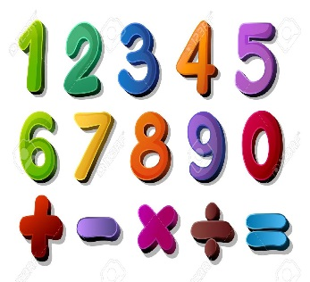 | We will be;  - Creating number bonds within 10  - Finding parts  - Addition and subtraction within 10  - 2D shapes  - 3D shapes  - Patterns within shapes
SCIENCE | Year 1 – Animals including Humans  - We will be learning about animals and their offspring  - We will be finding out about and describing the basic needs of animals including humans for survival  - We will be describing the importance for humans of exercise, eating the right amounts of different types of food and hygiene
History – How has childhood changed? | We will be looking at changes within living memory and we will be comparing aspects of life in different memory.
History – How has childhood changed? | RE – How and why do we celebrate special and sacred times?  DT – Cooking  Music - Trafford Music Service on a Friday.  Computing – Programming  PE – taught by Mr Ritchie on a Wednesday – Please have PE kits in school.  PSE - Relationships  Art – Paul Klee
SPECIAL EVENTS/HOLIDAYS   | Please keep up-to-date with letters and our web page where you find all our special events organised!  Please refer to our school calendar 2023-2024 – reminders to follow as and when they occur.  Please keep your eye on Class Dojo for class and school information. If you need to contact me please do via Dojo or call the school.
READING   | We read every day in school using the Little Wandle Scheme (Big Cat Collins Books) to match the children’s assessed phonic ability. We will be assigning an E-Book to your child each week on a Friday.  Our Reading Scheme works in the following way; we do 3 reads per week using the Little Wandle Book.  Day 1 is for Decoding (Segmenting the sounds in words)  Day 2 is for Prosody (Fluency)  Day 3 is for Comprehension (answering questions about the story)  This book will then be assigned to your child so that they can continue reading it with you at home. This is so that they can build up their fluency in reading.

