
Class Plans
CLASS: Pearce Term: Autumn 1
SUBJECT | LEARNING
LITERACY  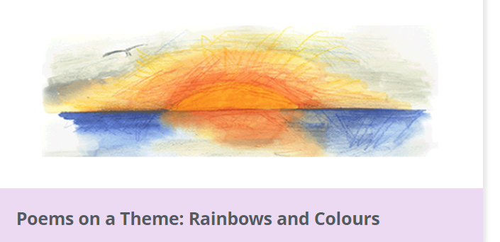 | Fiction – Adventure Stories  To begin the year we are looking at a poetry module which focuses on the theme, colours and rainbows. We begin by exploring some famous poetry on the subject and responding to it before looking at some prefixes and suffixes within poetry. We will conclude with some compositions of our own.
MATHEMATICS   | Place Value –recognise and use numbers up to 1000  Addition – two three and four digit addition  Subtraction - two three and four digit subtraction
Times Tables
Tames tables lessons take place once each week. We learn through a variety of fun and engaging activities.
SCIENCE | Animals including humans  - The human body  - Teeth  - Animals teeth  - Food chains  - The digestive system
OTHER TOPICS | History – Britain after the Romans  Music - with Beth from Trafford Music Service on Thursday  PE –Agility balance and co-ordinationon a Thursday with Mr Richie, Play to Learn on a Friday  RE – Christianity
SPECIAL EVENTS/HOLIDAYS   | Please keep up-to-date with letters and our web page where you find all our special events oraganised!  - Please refer to our school calender 2022-2023 reminders to follow as and when they occur.
HOMEWORK PRIORITIES   | There is no official homework that is set by class but please make sure to work with your child on:  - Maths: Practice times tables. All children have Times Table Rockstars logins and set times tables.  - English: Work on spellings from their reading books.  - Reading: Please read the book you take home every evening

INDIVIDUAL BEHAVIOUR TARGETS
Please refer to your child’s IEP and get in touch with the class teacher if you have any concerns.
....................................................................................................................................................


