
Class Plan
Class: Flannigan Term: Summer 2 2023
SUBJECT | LEARNING
LITERACY | - This term we will be reading the story of ‘Knuffle Bunny’  - We will be working on story ordering and story sequencing by creating story maps  - We will be changing parts of a story to create our own books  - We will been working on our sentence structures; writing from left to right, using capital letters, finger spaces and punctuation and making sure that we have orally rehearsed our sentence before we begin writing.  - We will be using our phonics mats to ensure we are using our segmenting skills to aid with our phonetic spelling of words
MATHS  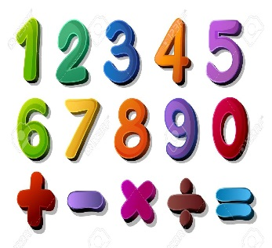 | We will be;  - Counting backwards from 10 and building our own number lines  - Finding 1 less than any given number within 10  - Learning how to share an amount equally  - Learning which groups have more, fewer, the same  - Learning the mathematical symbols for greater than, less than and equal to
SCIENCE  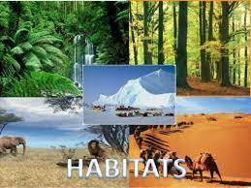 | Year 1 – Materials  - Identifying and naming different materials  - Learning the different properties of materials and the vocabulary surrounding this  - Everyday materials  - Testing properties and learning new vocabulary such as; transparent, opaque, waterproof, insulator  - We will be basing our work surrounding the story of ‘The Three Little Pigs’ and building our own houses for the pigs that are both sturdy and waterproof
History – How have toys changed? | Can I describe different toys?  Can I find out which toys my grandparents played with?  What were toys like at different times in the past?  Can I identify which toys are old and which are new?  Can I find out the similarities and differences of toys?  RE – Christianity – Pentecost  DT – Building structures and thinking about how they can be more stable, stiffer and stronger  Music - Trafford Music Service on a Thursday.  Computing – Programming  PE – taught by Mr Ritchie on a Wednesday – Please have PE kits in school.  Art – Banksy  Exploring and Developing Ideas, Work of Artists,  Printing  Looking at the work of an artist, craft makers and designers, describing the differences and similarities between different practices and disciplines, and making links to their own work.
SPECIAL EVENTS/HOLIDAYS   | Please keep up-to-date with letters and our web page where you find all our special events organised!  - Please refer to our school calendar 2022-2023 – reminders to follow as and when they occur.  Please keep your eye on Class Dojo for class and school information. If you need to contact me please do via Dojo or call the school.
READING  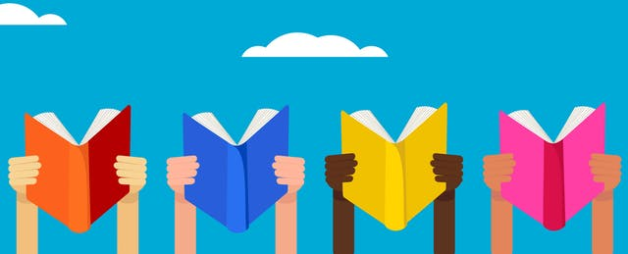 | We read every day in school and if possible, we would like you to read with your child each night. Please record this in your child’s reading record. Books go home on a Friday to be returned the following Friday. We will only change the book if it has been returned to school and a comment has been made by a parent or carer. Thank you

