Traditional Tales

Words we will use |  | Exciting Books we will read
Hero | Villain | 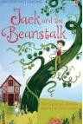  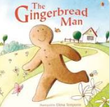  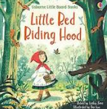  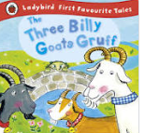  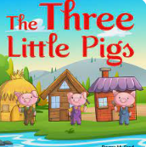  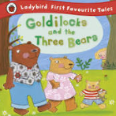
Setting | Traditional Tale
Character | Castle
Moat | Turret
Literacy |  | Understanding the World
Phonics / Reading | English | Through our topic, Traditional Tales, we will;  - Investigate and explore the natural world by looking at different habitats – meadows, fields and forests.  - Investigate different materials by creating a bridge strong enough for a toy, a new chair for Baby Bear and homes for the Three Little Pigs.  - Explore which objects can be ‘puffed’ and which cannot be ‘puffed’.  - Consider what makes us special and where we belong.  - Look at the clothes the characters wear in our stories and compare them with clothes we wear today.  - Explore and create maps from different starting points in our stories and in our school.  - Look at homes from a long time ago – Castles  - Find out about older and younger family members.
Daily Little Wandle Phonics Sessions with Phase 2 & 3 Sounds.  Guided Reading sessions focussing on:  Decoding  Fluency and Comprehension.  Daily Shared Reading sessions. | We will:  Continue to learn about the 5 key concepts print.  Use our exciting books to talk about stories and learn new vocabulary.  Continue to practise our lowercase letter formation.  Continue to practise writing our names.  Begin to compose simple phrases and imaginary sentences.
Maths | 3D Shapes and pattern  To 20 and beyond - Build numbers beyond 10, Count patterns beyond 10, Spatial reasoning 1, Match, rotate and manipulate.  First, The, Now – Adding more, Taking away, Spatial reasoning 2, Compose and decompose.  Find my pattern – Doubling, Sharing and grouping, Even and off, Spatial reasoning 3, Visualise and build.
Expressive Arts and Design | Art – Mask and puppets for our Traditional Tales.  Music – explore and engage in music making including singing and performing at our Class Awards.  DT – explore materials for a bridge strong enough for a toy, a chair for Baby Bear, and the homes for the Three Little Pigs.
Cultural Capital | We will learn about and celebrate:  18th June Father’s day  21st June World Music Day  28th June – Eid al-Adha  29th June – 19th July Children’s Art Week  30th July International Day of Friendship

