
Class Plan
Class: Lamb Term: Summer 2 2023
SUBJECT | LEARNING
LITERACY  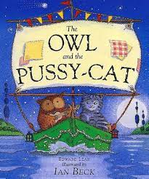 | This term we will be reading, learning and writing poems.  Poems with repeating patterns and rhymes – The Owl and The Pussycat  SPAG: Identify verbs in present and past tenses adding suffixes.  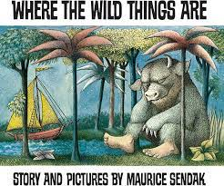  Comprehension: Read and learn by heart poems, recite and evaluate poetry.  Where the Wild Things Are  To plan and write a story  To write a character description  To write a setting description
MATHS  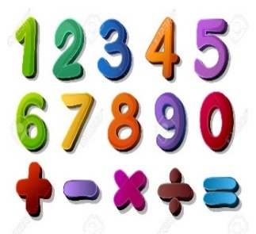 | Summer 2  Year 1  (2 weeks) Measurement length and height and mass and volume  (2 weeks) Statistics  (2 weeks) Time | Summer 2  Year 2  (2 weeks) Measurement length and height and mass and volume  (2 weeks) Statistics  (2 weeks) Time
SCIENCE  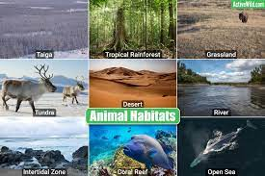 | Year 2  Living things and their habitats  To find out about and describe the basic needs of animals, including humans, for survival (water, food and air), by identifying the ways that different animals meet their basic needs.  Explore and compare the differences between things that are living, dead, and things that have never been alive.  Identify that most living things live in habitats to which they are suited and describe how different habitats provide for the basic needs of different kinds of animals and plants, and how they depend on each other.  Identify and name a variety of plants and animals in their habitats, including micro-habitats.  Describe how animals obtain their food from plants and other animals, using the idea of a simple food chain, and identify and name different sources of food.
GEOGRAPHY and HISTORY   | Summer Topic: Locational/place knowledge - Sun, Sea, Sand  Seaside  Use basic geographical vocabulary to refer to: Key physical features, including: beach, cliff, coast, forest, hill, mountain, sea, ocean, river, soil, valley, vegetation, season and weather. Key human features, including: city, town, village, factory, farm, house, office, port, harbour and shop  Geographical skills and fieldwork  Use simple compass directions (north, south, east and west) and locational and directional language [for example, near and far, left and right], to describe the location of features and routes on a map. Draw or make a map of real or imaginary places (e.g. add detail to a sketch map from aerial photograph)  Use and construct basic symbols in a key.  RE – How should we care for others and the world, and why does it matter?  Art – Gustav Klimt – Collage and weaving Children can:  use a combination of materials that have been cut, torn and glued; sort and arrange materials; add texture by mixing materials; use key vocabulary to demonstrate knowledge and understanding in this strand: collage, squares, gaps, mosaic, features, cut, place, arrange.  DT – LED characters  Music - Trafford Music Service on a Thursday.  Computing – E Safety and multimedia  PE – taught by Mr Ritchie on a Thursday – Please have PE kits in school.
SPECIAL EVENTS/HOLIDAYS   | Please keep up-to-date with letters and our web page where you find all our special events organised!  - Please refer to our school calendar 2022-2023 – reminders to follow as and when they occur.  Blackpool Trip – Thursday 13th July
READING  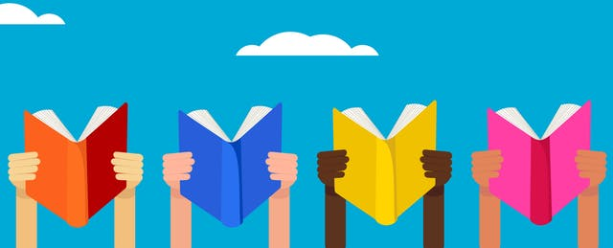 | We read every day in school.  Your child will be taking a reading book home to read with an adult. Please try and read a few pages with your child and record it in their reading record.

