Class Broomhead June 2023 – July 2023

SUBJECT | LEARNING
English - Letters  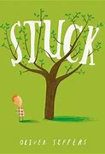 | - Children focus on two Oliver Jeffers books, Stuck and The Hueys: It Wasn’t Me. They look at the issues raised and use them to explore features of letter writing. They will have opportunities for role-play and discussion before writing letters themselves
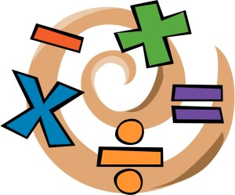  NUMERACY | - Shape (2 weeks)  - Measurements including time (4 weeks)
SCIENCE –  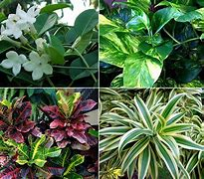  Y3 – Plants | - Identify and describe the functions of different parts of flowering plants: roots, stem/trunk, leaves and flowers  - Explore the requirements of plants for life and growth (air, light, water, nutrients from soil, and room to grow) and how they vary from plant to plant  - Investigate the way in which water is transported within plants
History – the history of sport  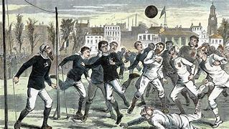 | - What was sport like in ancient times?  - What were/are the Olympics?  - How has football changed?
Other curriculum areas | PSHE – The importance of sleep, dental hygiene  Computing – Technology in our Lives  Art. - Edward Saidi Tingatinga  R.E – What does it mean to be a Christian in Britain today?  P.E – weekly session with Mr Ritchie  Music – Weekly session with Beth
At Home | - Reading nightly  - Times table practice (online games)

