
Class Plans
CLASS: Patel Term: Summer Term 2
SUBJECT | LEARNING
LITERACY | Fake News  Tackle the tricky issue of Fake News with this excellent block. Learn technical vocabulary, examine texts, carry out fact-checking and write a guide to help others. Incorporates modal verbs and adverbs and organisational devices.. Establish cross-curriculur links.  In conjunction, we will further strengthen our proper use of spelling, grammar and punctuation in our writing.
MATHEMATICS  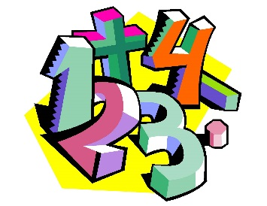 | Spring 2 – Year 5  Week 1-3 – Shape  Week 3-6 - Angles
Spring 2- Year 6
Week 1-3 – Ratio
Week 3-6 – Shape and Ratio

SCIENCE | Year 5 – Scientific Enquiries  - Bar charts  - Line Graphs  - Scatter Graphs  - Pie Charts | Year 6 – Scientific Enquiries  - Bar charts  - Line Graphs  - Scatter Graphs  - Pie Charts
OTHER TOPICS | Stone Age to Iron Age  This terms History topic is going to be looking at the change from Stone Age Britain to Iron Age Britain. We will investigate what made each era unique and the impact it has had on Britain as we see it now. We hope to carry out some fieldwork into our own community to help us with our understanding of our own area.  Music - with Beth from Trafford Music Service on Thursday. 1:1 on Fridays.  PE – Throwing and Catching with Mr Ritchie on Thursdays inc Boxing. Please ensure all children have a PE to participate. They will need shorts to participate.
SPECIAL EVENTS/HOLIDAYS   | Please keep up-to-date with letters and our web page where you find all our special events oraganised!  - Please refer to our school calender 2022-2023 – reminders to follow as and when they occur.
HOMEWORK PRIORITIES   | There is no official homework that is set by class but please make sure to work with your child on:  - Maths: Practice times tables. All children have Times Table Rockstars logins and set times tables.  - English: Work on spellings from their reading books.  - Reading: Please read the book you take home regularly

INDIVIDUAL BEHAVIOUR TARGETS
Please refer to your child’s IBP and get in touch with the class teacher if you have any concerns.
....................................................................................................................................................

