SUBJECT | LEARNING
English  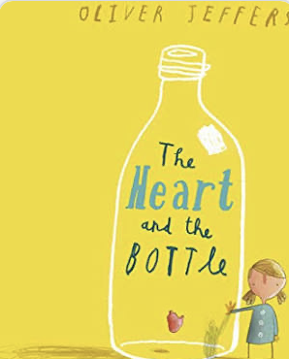 | - Fiction:  - The Heart and The Bottle by Oliver Jeffers  - The Red Tree by Shaun Tan  - Comparing stories that raise issues  - Comprehension  - Verbs & tenses  - Adverbials & fronted adverbials  - Descriptive writing about feelings & emotions  - Paragraphs  - Possessive apostrophes & commas  - Poetry:  - Syllabic Poems  - Syllables  - Importance of rhythm in poetry  - Understanding syllabic poetry  - Writing our own Haiku poems  - Weekly spelling/phonics activities
Maths | Group 1:  - Square & Cube numbers  - Formal written method of division  - Formal written method of multiplication  - Problem solving involving multiplication & division  Weekly times tables practice | Group 2:  - Identifying 3D shapes  - Properties of 3D shapes  - Column addition & subtraction.  - Addition and subtraction problems involving money  Weekly times tables practice
Science | Group 1: Forces  - Defining forces  - Gravity & air resistance  - Mechanisms, including levers & pulleys  - Friction  - Water resistance | Group 2: Electricity  - Sorting electrical and non-electrical items  - Building circuits  - Understanding different components  - Different conductors  - Electrical safety
History | - The Victorians  - Who was Queen Victoria?  - Schools in the Victorian times  - Victorian Clothing  - Inventions  - Crime & Punishment
Other Curriculum Areas | - Computing: E-safety & Multimedia  - RE: What does it mean to be a Christian/Hindu/Muslim in Britain today?  - PSHE: Physical health & the risks associated with an inactive lifestyle  - PE with Mr Ritchie: Athletics  - Music with Beth: Using music to express emotion  - DT: Wire maze games
Priorities | - Daily reading  - PE kit & trainers needed every Friday

Please also see your child’s IEP for their personalised targets relating to their EHCP.

