
Class Plan
Class: Flannigan Term: Summer 1 2023
SUBJECT | LEARNING
LITERACY | - This term we will be reading the stories of ‘This is the Bear and the scary night’ and ‘Five Minutes peace’.  - We will been working on our sentence structures; writing from left to right, using capital letters, finger spaces and punctuation and making sure that we have orally rehearsed our sentence before we begin writing.  - We will be using our phonics mats to ensure we are using our segmenting skills to aid with our phonetic spelling of words  - We have also been working on story ordering and story re-telling.
MATHS  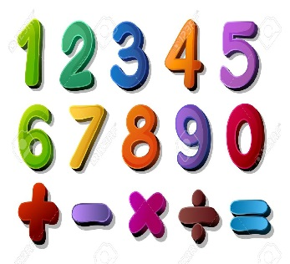 | We will be;  - working on ordering numbers within ten and looking at numbers in their written form.  - Learning our number bonds to 10  - Counting on from any number – number sequencing  - 1 more than a given number within 10  - Number formation
SCIENCE   | Year 1 – Animals including humans  - Labelling the parts of a human body  - Looking at animal groups and sorting animals into the correct groups according to their features (reptiles, mammals, fish, amphibians, birds)  - Animal diets – Learning that each animal belongs to a different dietary group and sorting them into the correct one (carnivores, omnivores, herbivores)  - Looking at features of different animals
Geography | Name and locate the five oceans of the world  Four countries of the United Kingdom  Learn the seven continents of the world  RE – Who is a Muslim and what do they believe?  DT – Using a range of materials and resources to practice cutting and joining skills  Music - Trafford Music Service on a Thursday.  Computing – Mouse skills  PE – taught by Mr Ritchie on a Wednesday – Please have PE kits in school.
SPECIAL EVENTS/HOLIDAYS   | Please keep up-to-date with letters and our web page where you find all our special events organised!  - Please refer to our school calendar 2022 – 2023 reminders to follow as and when they occur.  Please keep your eye on Class Dojo for class and school information. If you need to contact me please do via Dojo or call the school.
READING   | We read every day in school and if possible, we would like you to read with your child each night. Please record this in your child’s reading record. Books go home on a Friday to be returned the following Friday. We will only change the book if it has been returned to school and a comment has been made by a parent or carer. Thank you

