People who help us

Words we will use |  | Exciting Books we will read
Doctor | Vet | 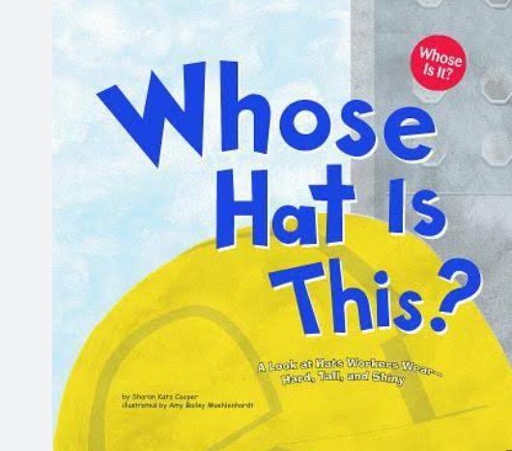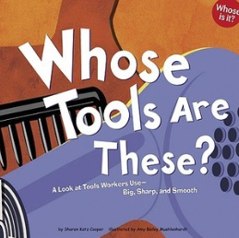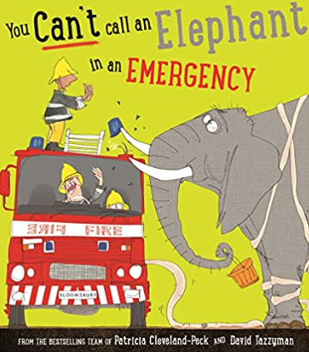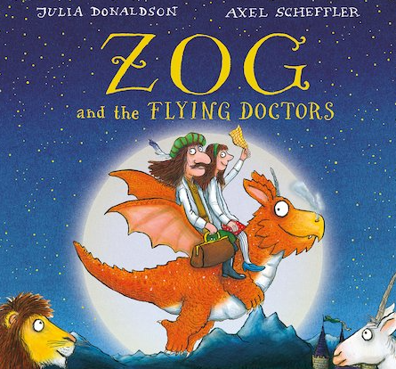  Various non fiction texts.
Ambulance | Dentist
Lifeguard | Safe
Emergency Services | Danger
Police Officer | Brave
Firefighter | Calm
Paramedic | Rescue
Literacy |  | Understanding the World
Phonics / Reading | English | Through our topic, People Who Help Us. We will;  - Talk about different occupations.  - Talk about people at home and school who help us.  - Name different types of people who help others.  - Talk about the people in our community who help others to keep safe and stay healthy.  - Talk about the roles people have in the community.  - Describe how the people in my community help others and the things they do in their jobs.
Daily Little Wandle Phonics Sessions with Phase 2 & 3 Sounds.  Guided Reading sessions focussing on:  Decoding  Fluency and Comprehension.  Daily Shared Reading sessions. | We will:  Continue to learn about the 5 key concepts print.  Use our exciting books to talk about stories and learn new vocabulary.  Continue to practise our lowercase letter formation.  Continue to practise writing our names.  Begin to compose simple phrases and imaginary sentences.
Maths | Counting to 9 & 10  Comparing numbers to 10  Bonds to 10
Expressive Arts and Design | Art –Printing crowns in the style of John Banting.  Music – explore and engage in music making including singing our People Who Help Us songs!  DT - Explore different materials to plan and create equipment used by people who help us.
Cultural Capital | We will learn about and celebrate:  St Georges Day.  The King’s Coronation.  International Nurses Day (12th May).

