
Class Plan
Class: Lamb Term: Summer 1 2023
SUBJECT | LEARNING
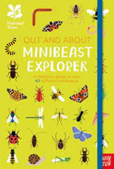  LITERACY | This term we will be reading, learning about and writing Information Texts.  - Enter the world of minibeasts and explore the features of a non-fiction text. We will learn how to use noun phrases in descriptive writing, use bullet points to make a list of equipment needed for a minibeast hunt and create our own information books about hidden minibeasts.  - SPAG - Descriptive writing – adjectives, prepositions and adverbs.
MATHS  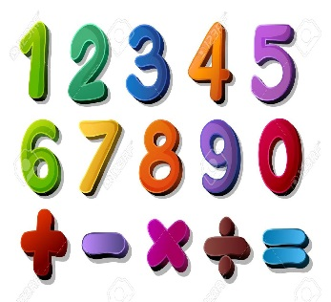 | Summer 1 and 2  Year 1 and 2  Multiplication and Division  Fractions – Name the fractions 1/3 ¼ ½ ¾  SATS practice
SCIENCE  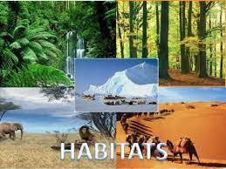 | Year 2 - Living things and their habitats  What questions do I have about this topic?  What are the differences between things that are living, dead and have never been alive?  What are habitats?  How can I map a habitat and identify what is in it?  How do I identify animals in their habitats?  How do I explain how living things in a habitat depend on each other?  Microhabitats  How do animals find their food?
History  Who was Mary Seacole?  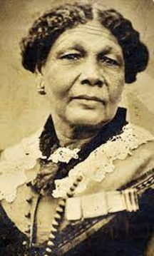 | Historical Enquiry  Ask and answer questions  Who was Mary Seacole?  What did she do? How did she make things change?  Interpreting History  Identify different ways that the past is represented e.g fictional accounts, illustrations, films, songs, museum displays  Continuity and Change  Discuss change and continuity in an aspect of life  Significance  Recognise and make simple observations about who was important in an historical event e.g talk about who was important and why.  RE – Who is a Muslim and what do they believe?  DT – Bird feeders  Music - Trafford Music Service on a Thursday.  Computing – E Safety and programming.  PE – taught by Mr Ritchie on a Thursday – Please have PE kits in school.  Art – Gustav Klimt  Exploring and Developing Ideas, Work of Artists,  Textiles weaving and decorating with glued on decorations  Collage selecting different colours & using a range of materials to create effect.  RE – What does it mean to belong to a faith community?  Music - Trafford Music Service on Tuesdays.  PE – taught by Mr Ritchie on Thursday – Please have your PE kit.
SPECIAL EVENTS/HOLIDAYS   | Please keep up-to-date with letters and our web page where you find all our special events organised!  - Please refer to our school calendar 2021-2022 – reminders to follow as and when they occur.  Please keep your eye on Class Dojo for class and school information. If you need to contact me please do via Dojo or call the school.
READING   | We read every day in school and if possible, we would like you to read with your child each night. Please record this in your child’s reading record.

