
Class Plans
Class: Shafai Term: Summer 1 2023
SUBJECT | LEARNING
LITERACY  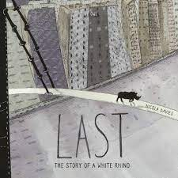 | We are looking at The Last by Nicola Davies which is a fact book all about the last white rhino and we will be looking at how we can help endangered animals to survive.  We will also be concentrating on spelling, punctuation and grammar looking at how we can improve our spellings.
MATHEMATICS  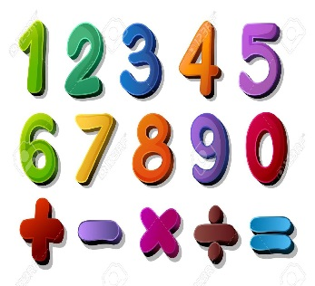 | Summer two  Money:  Learning what money looks like, recognising coins and notes and being able to add and subtract using money  Time:  We will be learning time to the minutes.  Statistics:  We will be learning about what statistics are and how we use them in every day life | Alongside our topics in Maths, we will also be focusing on our times tables once a week so that we can start to become fluent in them.
SCIENCE   | Summer two  We will be learning about electricity, how it works and how we can conduct it. We will be doing lots of experiments around this | We will think about our topic and come up with enquiry questions and find out the answers to our questions!
OTHER TOPICS  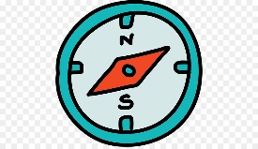  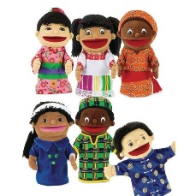 | Geography: We are looking at Biomes and vegetation and how we have different habitats depending upon where you live  DT: This term we will be focussing on food packaging and trying to make our own  RE – We are looking at different forms of religious expression  French- Every Tuesday with our teacher who comes from France  Music - with Beth from Trafford Music Service on Thursday.  PE – with Mr Ritchie on Wednesday.
SPECIAL EVENTS/HOLIDAYS   | Please keep up-to-date with letters and our web page where you find all our special events organised!  - Please refer to our school calendar 2022-2023 – reminders to follow as and when they occur.
READING   | We read every day in school and if possible, we would like you to read with your child each night.

INDIVIDUAL BEHAVIOUR TARGETS
Please refer to your child’s IBP and get in touch with the class teacher if you have any concerns.
...................................................................................................................................................

