
Class Plan
Class: Tan Term: Summer 1 2023
SUBJECT | LEARNING
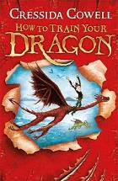  LITERACY | We will be discussing character descriptions, action/battle scenes and settings.  Areas of GAPS focus:  We will be looking at expanded noun phrases (with prepositional phrases) and figurative language. We will also learn to use a relative clauses and use adverbs  We will be writing with varied sentence openers and using dialogue to convey action and develop characters.  Areas of Writing Focus:  We will be identifying the audience for and the purpose of writing. We will look at how to use figurative language to create visual imagery. We will use dialogue to convey character and action in narrative.  We will write in paragraphs which can clearly signal a change in subject, time, place or event and we will use a range of sentence starters to create specific effects.
MATHS  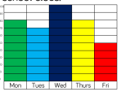  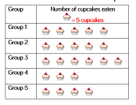  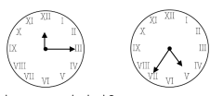 | Statistics  We will learn to create and interpret pictograms, bar charts and tables. Some of us will also look at using charts to calculate comparison, sum and difference.  Time  We will look at months and years and how many hours in a day. We will be abe to tell the time to 5 minutes and to the minute. We will use a.m. and p.m and the 24-hour clock. The children will learn how to find the duration, comparing durations and calculate start and end times. Children will also learn how to measure time in seconds.  Some of us will also learn how to convert analogue to digital.
SCIENCE  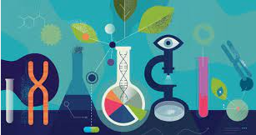 | Earth and Space  Children will continue with their Space topic at the beginning of this half term, continuing to learn about the Solar System and looking at the phases of the moon and explaining what causes them.  We will then move onto our next topic of forces. Children will:  - Explain that unsupported objects fall towards the Earth because of the force of gravity acting between the Earth and the falling object  - Identify the effects of air resistance, water resistance and friction, that act between moving surfaces.  - Recognise that some mechanisms, including levers, pulleys and gears, allow a smaller force to have a greater effect.
Geography  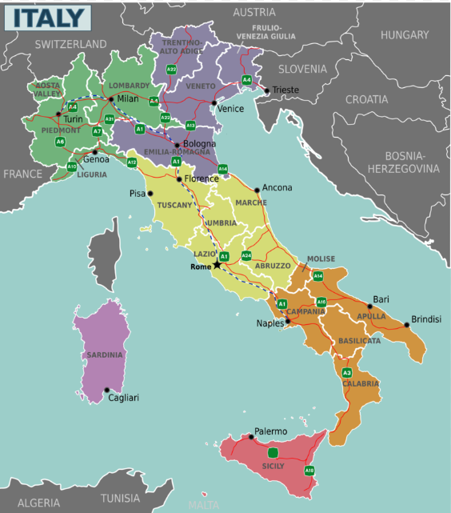 | In History, we will be doing an area study of Italy. We will look at how it has changed over time and the impacts of tourism. We will consider the North/South divide. We will compare different regions, looking at the human and physical geography, food and culture and areas of historical and cultural significance.  RE  - How should we care for others and the world, and why does it matter?  - What difference does it make to believe in…?  - Religions and worldviews: Hindus, Christians, Muslims, and Jewish people.  Music - Trafford Music Service on a Thursday.  Computing  - Handling Data  - E-Safety  - Multimedia  - Technology in our Lives  PE – will be on a Friday afternoon – Please have PE kits in school.
SPECIAL EVENTS/HOLIDAYS | Please keep up-to-date with letters and our web page where you find all our special events organised!  - Please refer to our school calendar 2022-2023 – reminders to follow as and when they occur.
READING   | We read every day in school.  Your child will taking a reading book home to read with an adult. Please try and read a few pages with your child and record it in their reading record.

