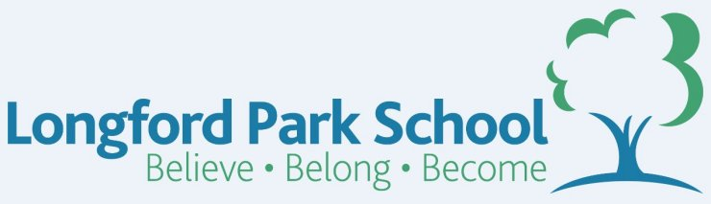
Class Plans
CLASS: Patel Term: SummerTerm 1
SUBJECT | LEARNING
LITERACY  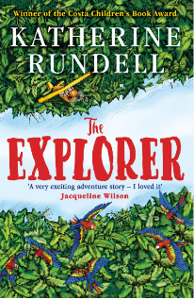 | When Stars are Scattered  Explore the brilliant graphic novel When Stars are Scattered, learning about how characters are developed through images and words. Grammar includes writing speech as well as adverbs of possibility and modal verbs. Establish cross-curriculur links.  In conjunction, we will further strengthen our proper use of spelling, grammar and punctuation in our writing.
MATHEMATICS   | Spring 2 – Year 5  Week 1-3 – Length & Perimeter  Week 3-6 - Measurment | Spring 2 – Year 5  Week 1-3 – Money linked to addition & Subtraction  Week 3-6 Length and Perimeter
Spring 2- Year 6
Week 1-3 – Perimeter and Area
Week 3-6 - Statistics

  SCIENCE | Year 5 – Electricity  - Electrical fun  - Understanding electrical safety  - Building a circuit  - Good conductor, Bad conductor  - Showing what you know | Year 6 – Properties and Changes in materials  - Soluble solutions  - Seperation solutions  - The Chemistry of cooking  - Oxidation  - The Chemistry Kitchen
OTHER TOPICS | Fieldwork  This terms Geography topic is going to be exploring our local community. We will investigate transport, maps, rivers, data collection and environmental issues. We hope to carry out some fieldwork into our own community to help us with our understanding of our own area.  Music - with Beth from Trafford Music Service on Thursday. 1:1 on Fridays.  PE – Throwing and Catching with Mr Ritchie on Thursdays inc Boxing. Please ensure all children have a PE to participate. They will need shorts to participate.
SPECIAL EVENTS/HOLIDAYS   | Please keep up-to-date with letters and our web page where you find all our special events oraganised!  - Please refer to our school calender 2022-2023 – reminders to follow as and when they occur.
HOMEWORK PRIORITIES   | There is no official homework that is set by class but please make sure to work with your child on:  - Maths: Practice times tables. All children have Times Table Rockstars logins and set times tables.  - English: Work on spellings from their reading books.  - Reading: Please read the book you take home regularly

INDIVIDUAL BEHAVIOUR TARGETS
Please refer to your child’s IBP and get in touch with the class teacher if you have any concerns.
....................................................................................................................................................

