SUBJECT | LEARNING
English  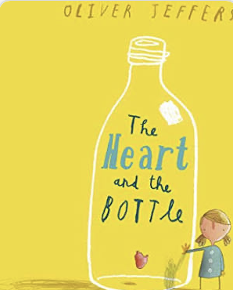 | - Non-fiction  - Horrible Histories Books  - Features of instructions  - Comprehension  - Features of explanation texts  - Paragraphs & headings  - Possessive apostrophes & commas  - Fiction:  - The Heart and The Bottle by Oliver Jeffers  - The Red Tree by Shaun Tan  - Comparing stories that raise issues  - Comprehension  - Verbs & tenses  - Adverbials & fronted adverbials  - Descriptive writing about feelings & emotions  - Weekly spelling/phonics activities
Maths | Group 1:  - Statistics  - Properties of polygons & quadrilaterals  - Drawing & reflecting shapes on a coordinates grid  - Position & direction  - Problem solving involving 2D & 3D shapes  Weekly times tables practice | Group 2:  - Bar charts & pictograms  - Identifying 3D shapes  - Properties of 3D shapes  - Position & direction  - Telling the time  Weekly times tables practice
Science | Group 1: States of matter  - Evaporation  - Condensation  - Reversible & irreversible changes  - The water cycle | Group 2: Properties of materials  - Classifying and grouping  - Thermal insulators and conductors  - Scientific enquiry skills  - Absorbency  - Sound proofing
Geography | - Tourism in Italy  - The location and physical features of Italy  - Italy’s climate  - Popular tourist destinations  - The impact of tourism on the economy  - Planning an itinerary for a trip to Italy
Other Curriculum Areas | - Computing: E-safety & Handling data  - RE: Is it better to express your beliefs in arts and architecture or in charity and generosity?  - PSHE: Physical health & the risks associated with an inactive lifestyle  - PE with Mr Ritchie: Striking & fielding skills  - Music with Beth: Using music to express emotion  - Art: Drawing, sculpture & painting
Priorities | - Daily reading  - PE kit & trainers needed every Friday

Please also see your child’s IEP for their personalised targets relating to their EHCP.

