Subject Specific Vocabulary |  | 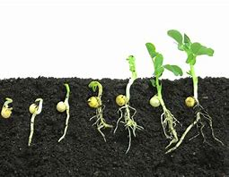  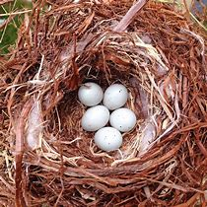  What grows in the garden? | Exciting Books
Word | Definition |  | 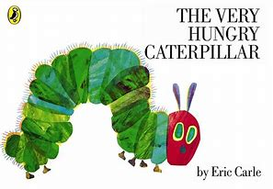  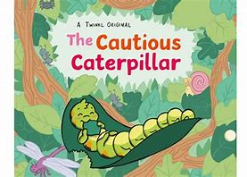  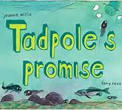  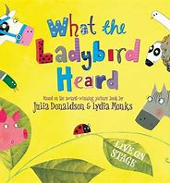  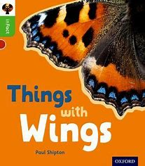  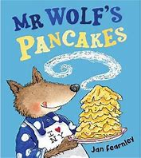
Spring | A season of the year between summer and winter
Seed | The small part of a flowering plant that grows into a new plant
Shoot | A bit of new growth
Root | The part of a plant that usually grows underground
Hatch | When young animals break out of their egg and are born
Leaves | One of the usually green, flat parts of a tree or plant that grows from the stem or branch
Egg | an oval or round object laid by a female bird, reptile, fish, or invertebrate that hatches
Larvae | The stage that an animal goes through in-between hatching and becoming an adult
Hook (Cultural Capital) | Key Learning Outcomes |  | Can I?
- Pancake Day | - I can recognise that people have different beliefs and celebrate special times in different ways.  - I can recognise some similarities and differences between life in this country and life in other countries.  - I can begin to combine two amounts |  | Can I write about my holiday news?  Can I listen carefully to a story and recall what happens?  Can I choose what my favourite pancake topping is then draw a picture and use my phonic skills to write about it?  Can I find a way to represent the number 6/7/8?
- World Book Day (2nd March), Butterfly Eggs, St David’s Day (1st March) | - I can explore the natural world around me  - I can describe what I can see, hear and feel  - I can begin to understand what a pair is |  | Can I celebrate World Book Day?  Can I understand what St David’s Day is and who celebrates it?  Can I begin to learn about the lifecycle of a butterfly?  Can I make a pair?
- Planting | - I can plant seeds and care for growing plants  - I can explore the world around me and draw pictures of animals and plants  - I can combine two amounts |  | Can I plant a seed and learn how it grows?  Can I label the parts of a plant?  Can I learn a fact about a butterfly?  Can I combine two amounts to work out how many I have altogether?
- St Patrick’s Day (17th March), Mother’s Day Afternoon Tea (19th March) | - I can talk about the lives of the people around me  - I can understand the concept of length |  | Can I understand what St Patrick’s Day is and who celebrates it?  Can I talk about who is special to me and why?  Can I make a Mother’s Day card?  Can I begin to understand the lifecycle of a frog?
- Ramadan, Ladybirds | - I can recognise that people have different beliefs and celebrate special times in different ways.  - I can name the days of the week |  | Can I understand what Ramadan is and who celebrates it?  Can I begin to learn about the lifecycle of a ladybird?  Can I learn a fact about a bumblebee?  Can I name the days of the week?  Can I discuss the events that happen in my week?
- Easter celebrations | - I can understand the similarities and differences between different religions and cultural communities in this country  - I can combine shapes to make new shapes |  | Can I understand what Easter is and who celebrates it?  Can I listen to the Easter story?  Can I retell the Easter story?  Can I make an Easter Bonnet?  Can I combine shapes to make a new shape?
Where in the World? | Week 1: France  Week 2: Wales  Week 3: Colombia  Week 4: Ireland  Week 5: Albania  Week 6: Jerusalem

