Class Plan
Class: Lamb Term: Spring 2023
SUBJECT | LEARNING
LITERACY  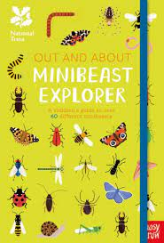 | This term we will be reading, learning about and writing Information Texts.  Enter the world of minibeasts and explore the features of a non-fiction text. We will learn how to use noun phrases in descriptive writing, use bullet points to make a list of equipment needed for a minibeast hunt and create our own information books about hidden minibeasts.  SPAG - Descriptive writing – adjectives, prepositions and adverbs.
MATHS  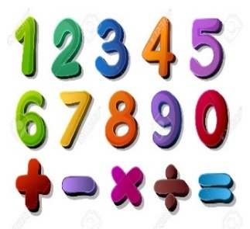 | Spring 2  Year 1  Multiplication and division (3 weeks)  Counting in steps of 2, 5 and 10.  Solve a one-step problem involving a multiplication and division, using concrete objects, pictorial representations and arrays | Spring 2  Year 2  Multiplication and division  Counting in steps of 2,3 5 and 10.  Recall and use multiplication and division facts for the 2, 5 and 10x multiplication tables.  Fractions - Name the fractions 1/3; ¼; ½ and ¾ and find fractional values of shapes; lengths and numbers
SCIENCE  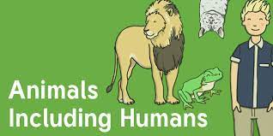  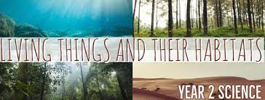 | Year 2  Animals including humans  Describe the importance for humans of exercise, eating the right amounts of different types of food, and hygiene.  Living Things and Their Habitats  Explore and compare the differences between things that are living, dead, and things that have never been alive.  Identify that most living things live in habitats to which they are suited and describe how different habitats provide for the basic needs of different kinds of animals and plants, and how they depend on each other.  Identify and name a variety of plants and animals in their habitats, including micro-habitats.  Describe how animals obtain their food from plants and other animals, using the idea of a simple food chain, and identify and name different sources of food.
HISTORY  Who was Mary Seacole?  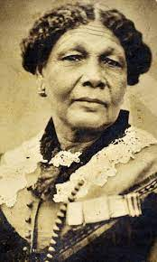 | Historical Enquiry  Ask and answer questions  Who was Mary Seacole?  What did she do? How did she make things change?  Interpreting History  Identify different ways that the past is represented e.g fictional accounts, illustrations, films, songs, museum displays  Continuity and Change  Discuss change and continuity in an aspect of life  Significance  Recognise and make simple observations about who was important in an historical event e.g talk about who was important and why.  RE – Who is a Muslim and what do they believe?  Art – Romero Britto – Drawing and painting.  DT – Bird feeders  Music - Trafford Music Service on a Thursday.  Computing – E Safety and programming.  PE – taught by Mr Ritchie on a Wednesday – Please have PE kits in school.
SPECIAL EVENTS/HOLIDAYS | Please keep up-to-date with letters and our web page where you find all our special events organised!  - Please refer to our school calendar 2022-2023 – reminders to follow as and when they occur.
READING  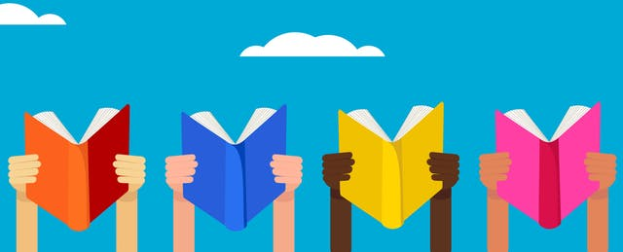 | We read every day in school.  Your child will be taking a reading book home to read with an adult. Please try and read a few pages with your child and record it in their reading record.

