
Class Plan
Class: Tan Term: Spring 2 2023
SUBJECT | LEARNING
LITERACY  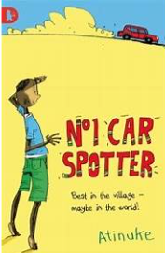  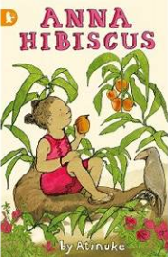 | No1 Car Spotter  Anna Hibiscus  This half term, we will be reading two books - No1 Car Spotter and Anna Hibiscus. They are both set in Africa and expertly weave cultural details into easily relatable daily-life stories.  The first book tells the story of No. 1, whose hobby is car spotting but who is good at solving all sorts of problems for his village. When the family’s cart breaks down and there’s no way of bringing goods to market, it’s No. 1 who devises the Toyota Cow-rolla and saves the day. He runs errands for his family and helps Mama Coca-Cola feed the busloads of people who stop for her delicious fried akara. No. 1 even helps Grandmother get to the medical centre when she can’t afford treatment.  In Anna Hibiscus, we meet Anna who lives in a modern day African city with her parents, twin brothers and lots of relatives. Anna is very curious. She splashes in the sea, prepares for a party, sells oranges … and longs to experience snow!  As well as practising speech punctuation, we will also to relate to the emotions in the story and to No. 1’s dilemma about whether he was right to let Dad have the wheelbarrows.  Both these stories are tales of daily life. The children will read a similar ‘daily life’ story towards the end of the half term.  We will also practise punctuating direct speech, look at different verb tenses and draw comparisons between the two books.
MATHS  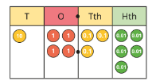  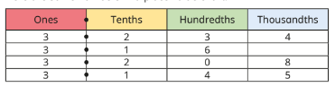  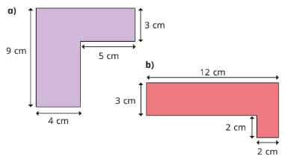 | Decimal Fractions.  Continuing our work on fractions, we are moving on to look at decimal fractions. Children will learn to recognise and write decimal equivalents of any number of tenths or hundredths and recognise and write decimal equivalents to ¼ , ½ and ¾  We will learn to add and subtract fractions with the same denominator (using diagrams) and solve simple measure and money problems involving fractions and decimals to two decimal places  Perimeter and Shape  We will compare and classify geometric shapes, including quadrilaterals and triangles, based on their properties and sizes. Children will also identify lines of symmetry in 2-D shapes presented in different orientations.  We will learn about symmetry and continue to identify horizontal and vertical lines and pairs of perpendicular and parallel lines. We will look at acute and obtuse angles and compare and order angles up to two right angles by size
SCIENCE  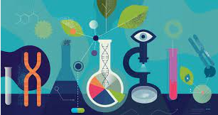 | Earth and Space  Children will research different planets and objects in the Solar System and create a fact sheet to present to the class.  We will find out about the planets in our solar system and use fruit to illustrate the comparative size of the planets.  Children will name the phases of the moon and explain what causes them.  We will find out and describe how light travels and explain how light from the sun affects day and night and the seasons.  We will then use our scientific enquiry skills to investigate life on other planets.
History | 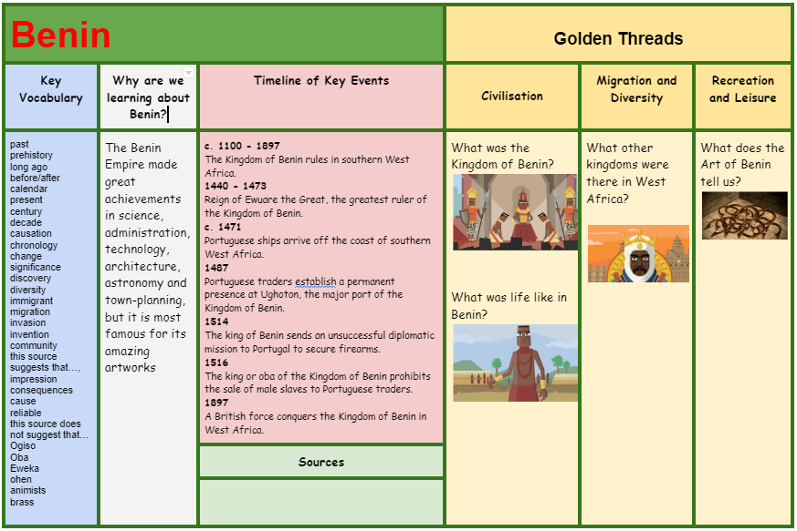  RE – What does it mean to be a Hindu in Britain today?  What is good and what is challenging about being a teenage Buddhist, Sikh or Muslim in Britain today?  Religions and worldviews: Muslims  Music - Trafford Music Service on a Thursday.  Computing – Handling Data  I can talk about the different ways data can be organised.  I can search a ready-made database to answer questions.  I can collect data to help me answer a question.  I can add to a database.  I can make a branching database.  I can use a data logger to monitor changes and can talk about the information collected.  PE – Swimming will be on a Friday afternoon – Please have PE kits in school.
SPECIAL EVENTS/HOLIDAYS | Please keep up-to-date with letters and our web page where you find all our special events organised!  - Please refer to our school calendar 2022-2023 – reminders to follow as and when they occur.
READING   | We read every day in school.  Your child will taking a reading book home to read with an adult. Please try and read a few pages with your child and record it in their reading record.

