
Class Plans
Class: Shafai Term: Spring 2 2023
SUBJECT | LEARNING
LITERACY  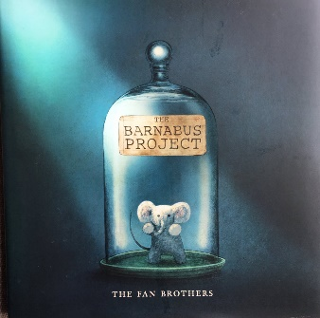 | We are looking at The Barnabus by The Fan Brothers which is a fiction book all about feeling out of place and longing to become part of something and belong to a community. The themes running through this book are that failure is ok.  We will also be concentrating on spelling, punctuation and grammar.
MATHEMATICS  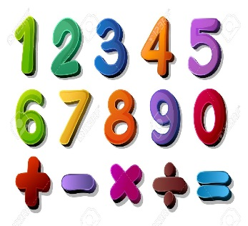 | Spring two  Fractions  Learning about fraction and how we divide items up into fractions  Length  Looking at perimeter and being able to measure using different measuring tools  Money  Learning what money looks like, recognising coins and notes and being able to add and subtract using money | Alongside our topics in Maths, we will also be focusing on our times tables once a week so that we can start to become fluent in them.
SCIENCE   | Spring two  We will be learning about state of matter which includes gases, liquids and solids. We will be conducting lots of experiments in this topic. | We will think about our topic and come up with enquiry questions and find out the answers to our questions!
OTHER TOPICS  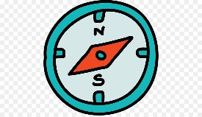  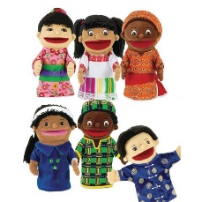 | History: We are looking at The Vikings and how they conquered England and stayed in power for so long  DT: This term we will be focussing on cooking and trying to make our own food.  RE – We are looking at different forms of religious expression  French- Every Tuesday with our teacher who comes from France  Music - with Beth from Trafford Music Service on Thursday.  PE – with Mr Ritchie on Wednesday .
SPECIAL EVENTS/HOLIDAYS   | Please keep up-to-date with letters and our web page where you find all our special events organised!  - Please refer to our school calendar 2022-2023 – reminders to follow as and when they occur.
READING   | We read every day in school and if possible, we would like you to read with your child each night.

INDIVIDUAL BEHAVIOUR TARGETS
Please refer to your child’s IBP and get in touch with the class teacher if you have any concerns.
...................................................................................................................................................

