SUBJECT | LEARNING
English | This term the books we will be focusing on are Michael Morpurgo’s sea stories. We will be reading: Dolphin Boy, The Sandman and the Turtles to explore his use of characterisation, dilemmas, dialogue, word classes and the perfect tense.  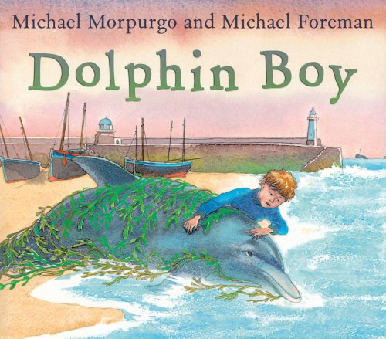
Maths | - Measuring Length and Perimeter  - Fractions and decimals  - Times tables practice  - Solve simple measure and money problems involving fractions and decimals to two decimal places  - Children will also identify lines of symmetry in 2-D shapes presented in different orientations
Science | Earth and Space  Children will research different planets and objects in the Solar System and create a fact sheet to present to the class.  We will find out about the planets in our solar system and use fruit to illustrate the comparative size of the planets.  Children will name the phases of the moon and explain what causes them.  We will find out and describe how light travels and explain how light from the sun affects day and night and the seasons.  We will then use our scientific enquiry skills to investigate life on other planets.
Geography | 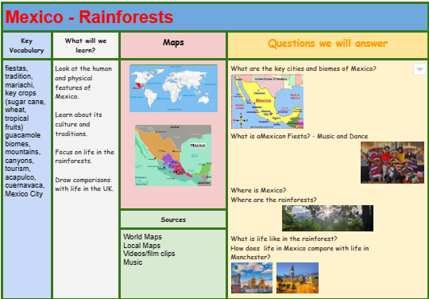
Other Curriculum Areas | - Computing: Programming  - RE: Expressing (Religious and spiritual forms of expression; questions about identity and diversity)  - PSHE: The importance of Taking part  - PE with Mr Ritchie/Boxing  - Music with Beth: Listening carefully & identifying different sounds
Priorities | - Daily reading  - Please ensure your child has a coat, bag and water bottle every day.  - PE kit & trainers needed every Thursday & Friday
Special Events

INDIVIDUAL BEHAVIOUR TARGETS
Please refer to your child’s IEP targets relating to their EHCP and get in touch with Mr Hadcroft if you have any concerns.
...................................................................................................................................................

