SUBJECT | LEARNING
English  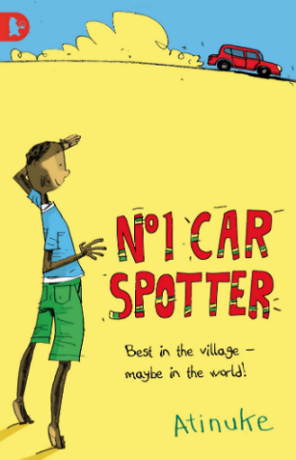 | - Poetry:  - I am the seed that grew the tree: A Nature Poem for Every Day of the Year by Fiona Waters and Fran Preston-Gannon  - Writing & performing our own poetry  - Fiction:  - The No1 car spotter by Atinuke  - Summarising & sequencing fictional stories  - Story reviews & comparisons, giving reasons for opinions.  - Punctuating direct speech  - Verbs – past, present & present perfect form  - Developing character profiles  - Planning & writing our own fictional stories  - Weekly spelling/phonics activities
Maths | Group 1:  - Measuring accurately.  - Different units of measurement  - Perimeter and area of composite rectilinear shapes  Weekly times tables practice | Group 2:  - Measuring accurately.  - M, cm & mm  - Comparing different measurements  - Addition & subtraction problems involving measures  Weekly times tables practice
Science | Group 1: Sound  - Sound reduction  States of matter  - Solids, liquids & gasses  - Particles  - Comparing & grouping different materials  - Evaporation & condensation | Group 2: Animals including Humans  - Changes in old age.  Earth & Space  - The sun, Earth & moon  - How the planets move around the sun  - Day, night & the Earth’s rotation  - Moon phases
History | - Benin Empire  - Timeline, location and the beginning of Benin  - Beliefs  - Artworks and artefacts  - The story of Eweka  - The end of the Benin Empire
Other Curriculum Areas | - Computing: E-safety & programming  - RE: Places of worship & Is it better to express your beliefs in arts and architecture or in charity and generosity?  - PSHE: Staying safe & Money management  - PE with Mr Ritchie: Throwing & catching  - Music with Beth: Exploring & comparing different instruments  - DT: Cooking bread
Priorities | - Daily reading  - PE kit & trainers needed every Friday

Please also see your child’s IEP for their personalised targets relating to their EHCP.

