SUBJECT | LEARNING
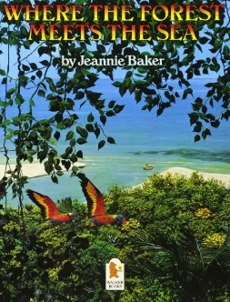  English | - Non-fiction:  - Where the forest meets the sea by Jeannie Baker  - Identifying the features of persuasive writing  - Recognising fact and opinion  - Researching for facts about the rainforest  - Planning a persuasive piece of writing to save the rainforest  - Writing our own persuasive texts to save the rainforest  - Poetry:  - I am the seed that grew the tree: A Nature Poem for Every Day of the Year by Fiona Waters and Fran Preston-Gannon  - Reading, comparing & discussing poems  - Identifying and using adverbials  - Writing poetry about the rainforest  - Weekly spelling/phonics activities
Maths | Group 1:  - Counting in fractions  - Finding fractions of amounts  - Right angles  - Parallel & perpendicular lines  Weekly times tables practice | Group 2:  - Improper & mixed number fractions  - Fraction, decimal & percentage equivalence  - Problems involving fractions, decimals & percentages  - Acute, obtuse & reflex angles  Weekly times tables practice
Science | Group 1: Sound  - Identifying how sounds are made  - Identifying how sounds travel to the ear  - Pitch & volume  - Sound reduction | Group 2: Animals including Humans  - Identifying how humans change as they age  - Comparing gestation in different animals  - Foetal development  - Adolescence & puberty  - The human timeline
Topic | - Geography: Mexico  - Location and map skills  - Land & different biomes  - Culture including music, costume and food  - Life in the rainforests
Other Curriculum Areas | - Computing: E-safety & programming  - RE: Places of worship & Is it better to express your beliefs in arts and architecture or in charity and generosity?  - PSHE: Taking part & staying safe  - PE with Mr Ritchie: Gymnastics  - Music with Beth: Tempo and pitch  - Art: Drawing, collage & textiles
Priorities | - Daily reading  - PE kit & trainers needed every Friday

Please also see your child’s IEP for their personalised targets relating to their EHCP.

