Class Broomhead January 2023 – February 2023

SUBJECT | LEARNING
English – Information Texts (Incredible Animals)  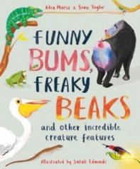 | - The differences between non-fiction and fiction texts.  - Comprehension of a non-fiction text  - Types of sentences  - The use of capital letters for proper nouns  - Writing a blog post about how to save wildlife
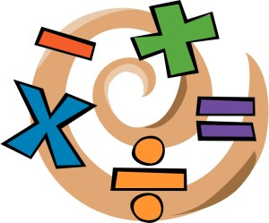  NUMERACY | - Written methods for addition and subtraction (1 week)  - Shape (2 weeks)  - Multiplication and division (3 weeks)
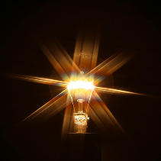  SCIENCE –  Y3 Light | - recognise that they need light in order to see things and that dark is the absence of light  - notice that light is reflected from surfaces  - recognise that light from the sun can be dangerous and that there are ways to protect their eyes  - recognise that shadows are formed when the light from a light source is blocked by an opaque object  - find patterns in the way that the size of shadows change
  Y4 – Sound | - identify how sounds are made, associating some of them with something vibrating  - recognise that vibrations from sounds travel through a medium to the ear  - find patterns between the pitch of a sound and features of the object that produced it  - find patterns between the volume of a sound and the strength of the vibrations that produced it  - recognise that sounds get fainter as the distance from the sound source increases
Geography – Rivers and mountains   | - Understand and describe the key aspects of physical geography including: rivers, mountains and the water cycle.  - Use maps, atlases, globes and digital computer mapping to locate countries and describe the features studied
Other curriculum areas | PSHE - Belonging to a community  Computing – Programming  D.T. - cooking  R.E – Who is Christian/ Muslim / Jewish and what do they believe?  P.E – weekly session with Mr Ritchie  Music – Weekly session with Beth
At Home | - Reading nightly

