Subject Specific Vocabulary |  | What does Winter Look Like?  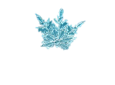 | Exciting Books
Word | Definition |  | 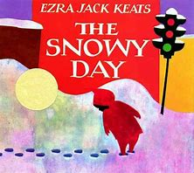  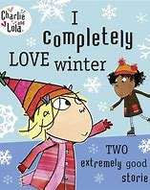  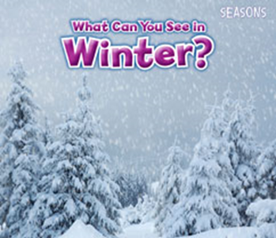  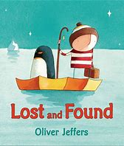
Winter | The coldest season of the year which takes place between December and February.
Season | A division of the year based on changes in the weather.
Weather | The day to day conditions of the atmosphere.
Snow | Water vapour that is frozen into ice crystals which then falls from the sky as white flakes
Frozen | When liquid turns to ice as a result of being extremely cold.
Ice | Frozen water.
Melting | When ice warms and turns into a liquid.
Hibernation | a deep sleep that helps animals to save energy and survive the winter without eating much
Waterproof | Keeps us dry.
Hook (Cultural Capital) | Key Learning Outcomes |  | Can I?
- Winter Walk – how can we tell it is winter? | - I can name the different parts of a book  - I can engage in extended conversations about a story  - I can use some of my print and letter knowledge in my writing  - I can write some letters accurately  - I can understand the effect of changing seasons on the natural world around me |  | Can I talk about the changes in the weather?  Can I compare the seasons and types of weather?  Can I write about my holiday news?  Can I write a thank you letter to Santa?
- Frozen animals – how can we rescue them? Penguin in our classroom with a ‘Lost and found’ tag on. | - I can make predictions about a story  - I can explore the natural world around me |  | Can I explore different ways to melt ice?  Can I make predictions in a story?  Can I make a lost poster?  Can I explore colour mixing?
- Chinese New Year, Dragon Dancing, Miss Leung to dress in traditional Chinese clothing | - I can recognise that people have different beliefs and celebrate special times in different ways  - I can use a range of different materials such as; rolled up paper, art straws and collaging to create a range of different Chinese New Year artwork  - I can recognise similarities and differences between life in this country and life in other countries |  | Can I find out about penguins?  Can I explore why the row boat floats?  Can I label the animals from the Chinese New Year story?  Can I create my own Chinese Dragon?
- LGBTQ+ History Month, NSPCC Number Day | - I can draw pictures of my house, school and other places in my local environment  - I can understand the need to care for the natural environment and all living things |  | Can I learn about other Arctic animals and why they are suited to their habitat?  Can I compare the arctic to our local area?
- Children’s Mental Health Week | - I can tell you some creatures that sleep at night and go to sleep (hibernate) in the winter  - I can identify and name native woodland creatures, talking about what they eat and where they might sleep |  | Can I investigate how animals keep warm in the winter? Link to habitats.
- Valentine’s Day, Shrove Tuesday. | - I can talk about how winter changes into spring  - I can show kindness towards others by being a good listener |  | Can I write about what my favourite pancake topping is?  Can I create and write a valentine’s card?  Can I remember the key features of spring?
Where in the World? | Week 1: Norway  Week 2: South Pole  Week 3: China  Week 4: Antarctica  Week 5: Canada  Week 6: Iceland

