
Class Plan
Class: Lamb Term: Spring 2023
SUBJECT | LEARNING
LITERACY  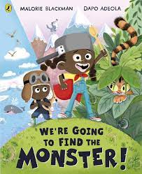 | This term we will be reading, learning and writing poems.  Poems with repeating patterns and rhymes.  SPAG: Identify verbs in present and past tenses adding suffixes.  Comprehension: Read and learn by heart poems, recite and evaluate poetry.  Poems on a Theme – Monsters - Reading a story and poems about monsters.
MATHS  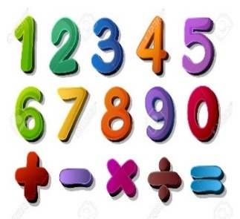 | Spring 1  Year 1  Money linked to addition and subtraction (3 weeks)  Multiplication and division (3 weeks) | Spring 2  Year 2  Money linked to addition and subtraction (3 weeks)  Multiplication and division (3 weeks)
SCIENCE  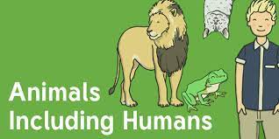 | Year 2  Animals including humans  To find out about and describe the basic needs of animals, including humans, for survival (water, food and air), by identifying the ways that different animals meet their basic needs.  To notice that animals, including humans, have offspring which grow into adults, by describing the changes to animals as they grow.  To identify, name, draw and label the basic parts of the human body.  To say which part of the body is associated with each sense in the context of drawing activities that use the sensory organs.  To perform simple tests in the context of investigating each of the five senses.  To identify and name a variety of common animals including, fish, amphibians, reptiles, birds and mammals.  To describe and compare the structure of a variety of common animals.  To identify and name a variety of common animals that are carnivores, herbivores and omnivores.
GEOGRAPHY    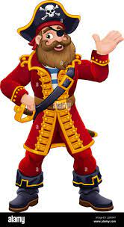 | Pirates - Where in the World are the Seven Seas and Five Oceans?  Locational knowledge  Name and locate the world’s 7 continents and 5 oceans.  Geographical skills and fieldwork  Use simple compass directions (north, south, east and west) and locational and directional language [for example, near and far, left and right], to describe the location of features and routes on a map. Draw or make a map of real or imaginary places (e.g. add detail to a sketch map from aerial photograph)  Use and construct basic symbols in a key.  RE – Who is a Muslim and what do they believe?  Art – Romero Britto – Drawing and painting.  DT – Bird feeders  Music - Trafford Music Service on a Thursday.  Computing – E Safety and programming.  PE – taught by Mr Ritchie on a Wednesday – Please have PE kits in school.
SPECIAL EVENTS/HOLIDAYS   | Please keep up-to-date with letters and our web page where you find all our special events organised!  - Please refer to our school calendar 2022-2023 – reminders to follow as and when they occur.
READING  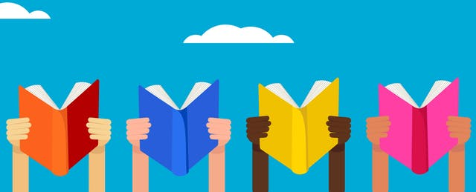 | We read every day in school.  Your child will be taking a reading book home to read with an adult. Please try and read a few pages with your child and record it in their reading record.

