
Class Plans
Class: Shafai Term: Spring 1 2023
SUBJECT | LEARNING
LITERACY  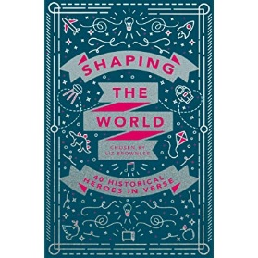 | We are looking at Poetry and our book is: Shaping the World by Liz Brownlee which is all about historical heroes.  We will also be concentrating on our punctuation and grammar and making our work very interesting by using lots of adjectives, nouns, verbs and adverbs.
MATHEMATICS  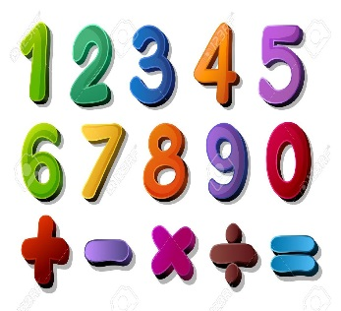 | Autumn two  Fractions: we will be looking at what fractions are and working on our fractions up to and including twelfths | Alongside our topics in Maths, we will also be focusing on our times tables once a week so that we can start to become fluent in them.
SCIENCE   | Autumn one  Sounds: We will be learning about what sounds are and how we can make them. We will also be looking at how our ears interpret sounds. | We will think about our topic and come up with enquiry questions and find out the answers to our questions!
OTHER TOPICS    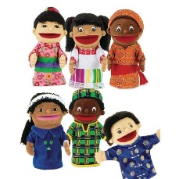 | Geography: We are looking at different climate zones and how climates impact on habitats  DT: This term we will be focussing on cooking and trying to make our own food.  RE – We are looking at different forms of religious expression  French- Every Tuesday with our teacher who comes from France  Music - with Beth from Trafford Music Service on Thursday.  PE – with Mr Ritchie on Friday .
SPECIAL EVENTS/HOLIDAYS   | Please keep up-to-date with letters and our web page where you find all our special events organised!  - Please refer to our school calendar 2022-2023 – reminders to follow as and when they occur.
READING   | We read every day in school and if possible, we would like you to read with your child each night.

INDIVIDUAL BEHAVIOUR TARGETS
Please refer to your child’s IBP and get in touch with the class teacher if you have any concerns.
...................................................................................................................................................

