
Class Plan
Class: Tan Term: Spring 1 2023
SUBJECT | LEARNING
LITERACY  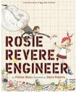 | Rosie Revere Engineer  Key Themes:  Growth mindset - not giving up  Attitudes to failure  What is an engineer - problem solving  Areas of Writing Focus:  Present a point of view in the form of a letter linking points persuasively and selecting style and vocabulary appropriate to the reader.  Write instructions for their invention.  Write a persuasive letter to an engineer persuading her to use your invention.  We will use the plan, draft, edit and publish writing cycle.  SPAG:  Question marks  Exclamation marks  Apostrophes for contractions and possession  Commas for sentence of 3 description  Prefixes and Suffixes  Past, present and future tense  Powerful verbs  Boastful language  Specific or technical vocabulary  Long sentences for description  Compound sentences  Commas for marking a subordinate clause
MATHS  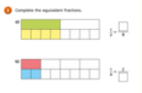  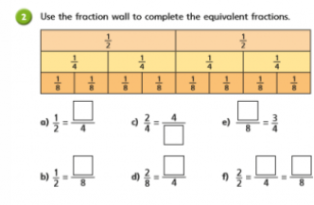 | Fractions.  Recap what a fraction is and what the different parts of a fraction represent as well as representing fractions in different ways.  Understand that finding a fraction of an amount relates to division  Recognise, find and write fractions of a discrete set of objects: unit fractions and non-unit fractions with small denominators  Recognise and use fractions as numbers: unit fractions and non-unit fractions with small denominators  Recognise and show, using diagrams, equivalent fractions with small denominators  Compare and order unit fractions, and fractions with the same denominators (including on a number line)  Count on and back in steps of unit fractions  Recognise and write decimal equivalents of any number of tenths or hundredths  Add and subtract fractions with the same denominator (using diagrams)
SCIENCE   | Animals Including Humans  We will be looking at the lifecycle of humans in Science this half term. Topics we will cover will include:  How do humans change during their lifetime?  What changes happen to babies and children?  What changes happen in adolescence and puberty?  What are the main changes that take place in old age?  As part of this topic, we will be talking about puberty and changes that happen to human bodies as they age. This can be a sensitive topic for some so please feel free to cantact me if you would like to know more about this.
Geography | 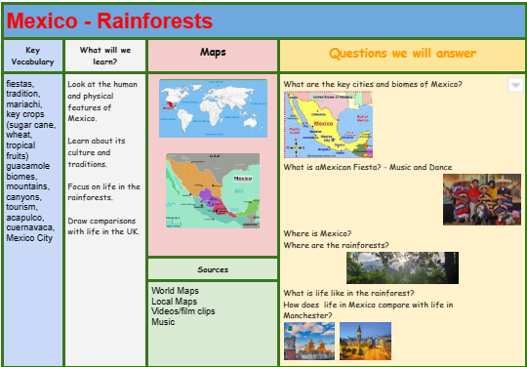  RE – What does it mean to be Muslim in Britain today?  Where do we belong?  What does it mean to belong to a faith community?  What does it mean to be a Christian in Britain today?  What does it mean to be a Hindu in Britain today?  Music - Trafford Music Service on a Thursday.  Computing – Re-cap of E Safety  - Programming  PE – taught by Mr Ritchie on a Wednesday – Please have PE kits in school.
SPECIAL EVENTS/HOLIDAYS  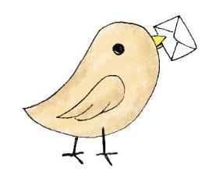 | Please keep up-to-date with letters and our web page where you find all our special events organised!  - Please refer to our school calendar 2022-2023 – reminders to follow as and when they occur.
READING   | We read every day in school.  Your child will taking a reading book home to read with an adult. Please try and read a few pages with your child and record it in their reading record.

