
Class Plans
CLASS: Pearce Term: Spring 1
SUBJECT | LEARNING
LITERACY  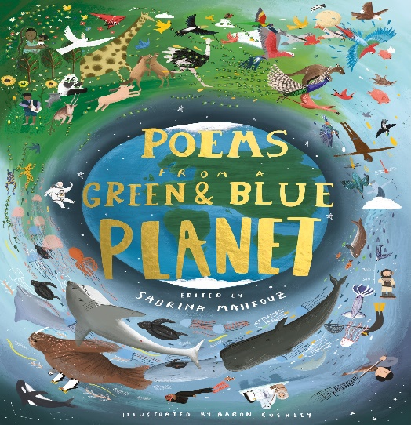 | Poems From a Green and Blue Planet  This term to start off with we are exploring poetry from, “Poems from a green and blue planet”. We will explore the punctuation and vocabulary within poetry before composing our own pieces and performing them from memory.  Our second text from this half term is The Explorer by Katherine Rundell.
MATHEMATICS   | Autumn 2 Year five  Unit 1 – fractions, equivalent fractions, adding fractions within 1  Decimals and percentages  Unit 2 – Perimeter and Area | Autumn 2 Year 6  Unit 1 – Fractions decimals and percentages, adding subtracting multiplying and dividing fractions  Unit 2 – area perimeter length and ratio
Times Tables
Tames tables lessons take place once each week. We focus on filling any gaps children may have through a variety of fun and engaging activities.
SCIENCE | Light  - Where does light come from?  - What do we need to be able to see?  - How fast does light travel?  - Creating our own periscopes  - Does light travel in straight lines?
OTHER TOPICS | Geography – Earth Matters. This half term we will be exploring Earthquakes and Volcanoes, what causes an earthquake or volcano. How do we measure these natural events, how can we stay safe when they take place?  Music - with Beth from Trafford Music Service on Friday.  PE – gymnastics on a Thursday with Mr Richie, Play to Learn with Mr Roberts on a Friday  RE – Judaism and Christianity
SPECIAL EVENTS/HOLIDAYS   | Please keep up-to-date with letters and our web page where you find all our special events oraganised!  - Please refer to our school calender 2022-2023 reminders to follow as and when they occur.
HOMEWORK PRIORITIES   | There is no official homework that is set by class but please make sure to work with your child on:  - Maths: Practice times tables. All children have Times Table Rockstars logins and set times tables.  - English: Work on spellings from their reading books.  - Reading: Please read the book you take home every evening

INDIVIDUAL BEHAVIOUR TARGETS
Please refer to your child’s IEP and get in touch with the class teacher if you have any concerns.
....................................................................................................................................................

