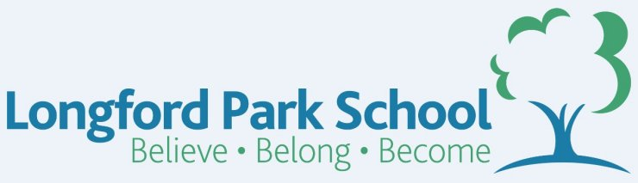
Class Plans
CLASS: Patel Term: Spring Term 1
SUBJECT | LEARNING
LITERACY  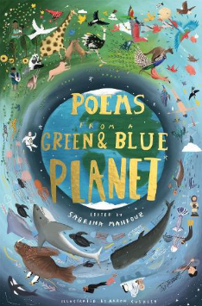 | Poems from a Green and Blue Planet, edited by Sabrina Mahfouz  This term we will be reading and enjoying a selection of poems from this wonderful anthology. Focus on poetic features and language, looking at their effects on the reader. Explore synonyms and antonyms using dictionaries and thesauruses. Express ideas and thoughts creatively in their own poetry. Learn how to integrate dialogue and to use expanded noun phrases. Improvise, draft, write and perform a playscript based on the book. Establish cross-curriculur links.  In conjunction, we will further strengthen our proper use of spelling, grammar and punctuation in our writing.
MATHEMATICS  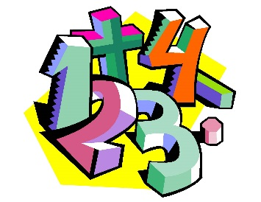 | Spring 2 – Year 5  Week 1-3 - Fractions  Week 3-6 - Shape | Spring 2 – Year 5  Week 1-3 - Fractions and Decimals  Week 3-6 Length and Perimeter
Spring 2- Year 6
Week 1-2 - Fractions B
Week 2-6 - Decimals and Percentages
  SCIENCE | Year 5 – Sound  - Sounds Walk  - Good Vibrations  - Pitch and Volume  - Pardon?  - Sshhh! | Year 6 – Animals inc Humans  - Gestation Gurus  - Feotal Development  - Baby & Child  - Adolescence & Puberty  - Adults & Old Age
OTHER TOPICS | Earth Matters  This terms Geography topic is going to be learning about how the importance of the earth makes it a sustainable planet for life to thrive.. We will investigate the features of the earth including Oceans, Mountains, Volcanoes, Tree life and Human Geography. We hope to carry out some fieldwork into our own community to help us with our understanding of our own area.  Music - with Beth from Trafford Music Service on Thursday. 1:1 on Fridays.  PE – Gymnastics with Mr Ritchie on Thursdays. Please ensure all children have a PE to participate. They will need shorts to participate.
SPECIAL EVENTS/HOLIDAYS   | Please keep up-to-date with letters and our web page where you find all our special events oraganised!  - Please refer to our school calender 2022-2023 – reminders to follow as and when they occur.
HOMEWORK PRIORITIES   | There is no official homework that is set by class but please make sure to work with your child on:  - Maths: Practice times tables. All children have Times Table Rockstars logins and set times tables.  - English: Work on spellings from their reading books.  - Reading: Please read the book you take home regularly

INDIVIDUAL BEHAVIOUR TARGETS
Please refer to your child’s IBP and get in touch with the class teacher if you have any concerns.
....................................................................................................................................................

