Longford Park Mathematics Progression Map
Scheme of Learning Objectives
- At Longford Park School we follow the white rose teaching for mastery mathematics scheme. This scheme supports a mastery approach to teaching and learning which is aligned with the objectives of the national curriculum.

Objectives Strategies
- Putting number first – A significant amount of time is spent reinforcing number in order to build competency and ensure children can confidently access the rest of the curriculum
- Depth before Breadth – The scheme supports teachers to stay within the required key stage so that children acquire depth of knowledge in each topic. Opportunities to revisit previously learned skills are built into later blocks.
- Working together – Children can progress through the scheme as a whole group, encouraging students of all abilities to support each other in their learning.
- Fluency Reasoning and Problem Solving – The scheme develops all three key areas of the national curriculum giving children the knowledge and skills they need to become confident mathematicians.
Strategies
- Concrete – Children should have the opportunity to work with physical objects / concrete resources in order to bring the maths to life and to build understanding of what they are doing.
- Pictorial – Alongside concrete resources, children should work with pictorial representations, making links to the concrete. Visualising a problem in this way can help children to reason and to solve problems.
- Abstract – With the support of both the concrete and pictorial representations, children can develop their understanding of abstract methods.

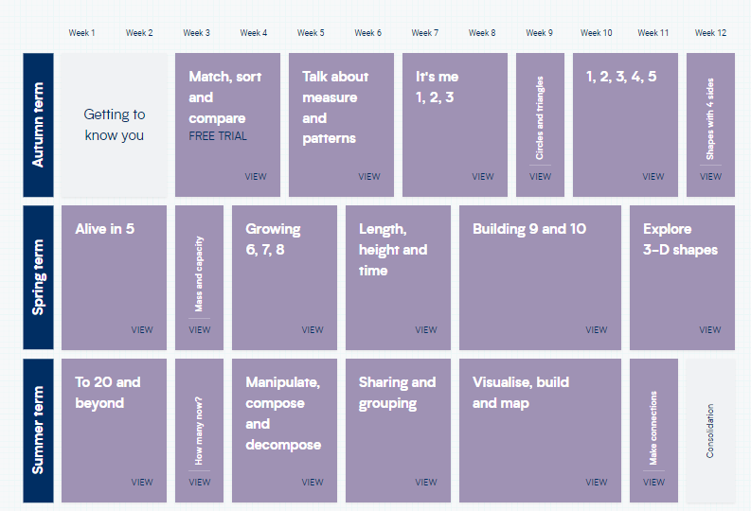Year 1
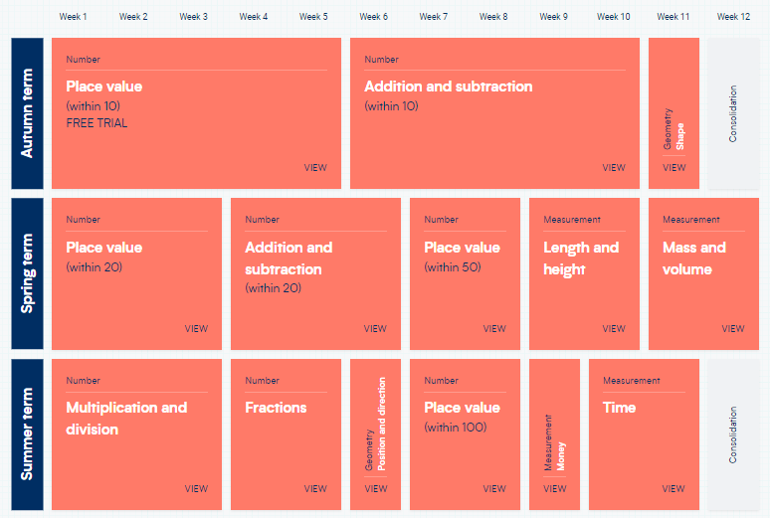
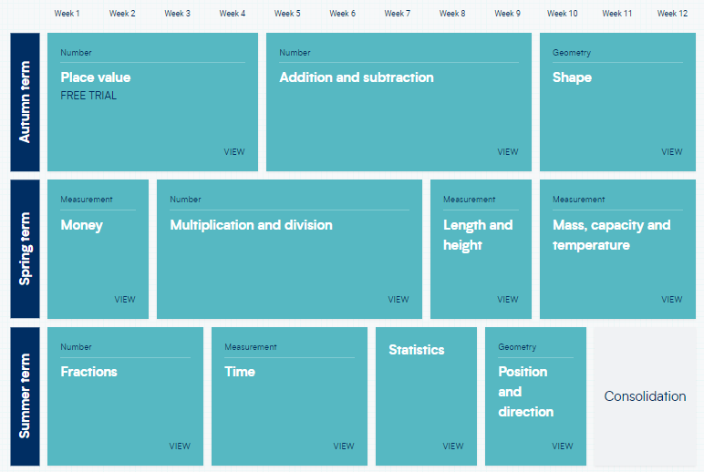
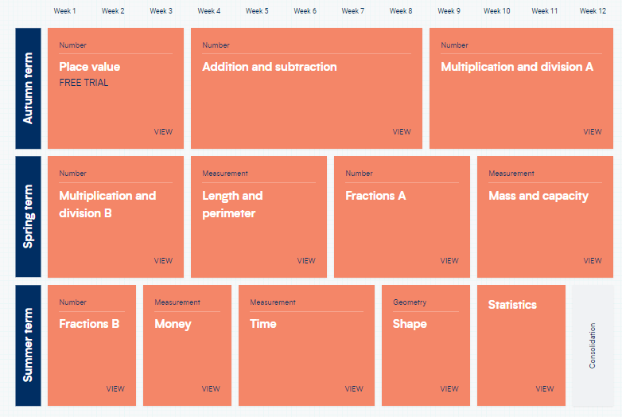
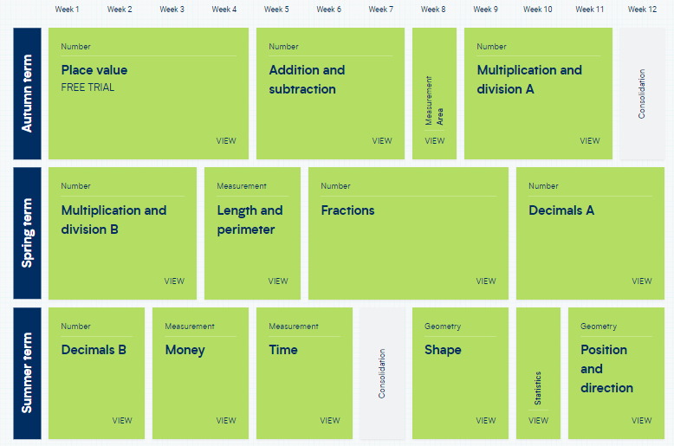
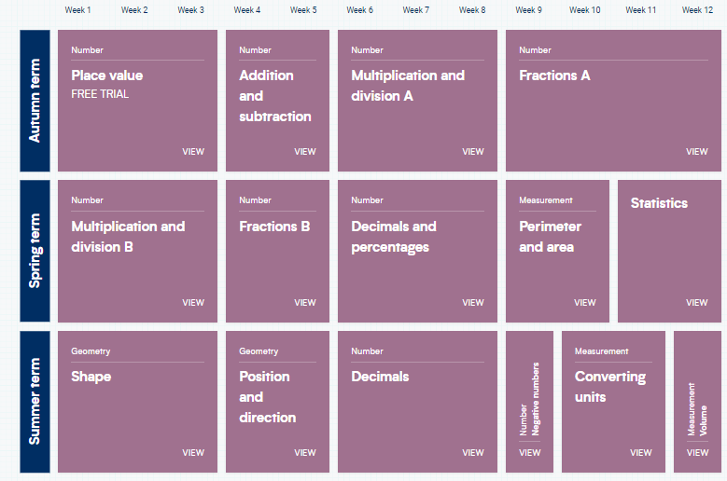
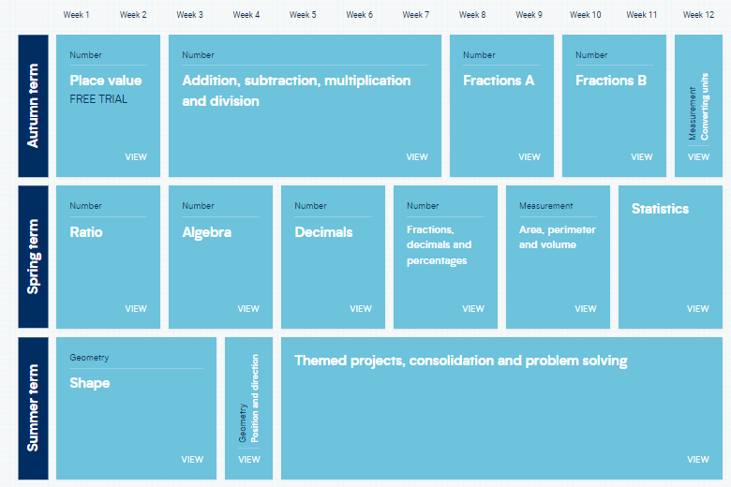
Place Value
EYFS | Year 1 | Year 2 | Year 3 | Year 4 | Year 5 | Year 6
- Step 1 Find 1, 2 and 3  - Step 2 Subitise 1, 2 and 3  - Step 3 Represent 1, 2 and 3  - Step 4 1 more  - Step 5 1 less  - Step6 Composition of 1, 2 and 3  - Step 1 Find 6, 7 and 8  - Step 2 Represent 6, 7 and 8  - Step 3 1 more  - Step 4 1 less  - Step 5 Composition of 6, 7 and 8  - Step 6 Make pairs-odd and even  - Step 7 Double to 8 (find a double)  - Step 8 Double to 8 (make a doubl  - Step 9 Combine 2 groups  - Step 10 Conceptual subitising  - Step 1 Build numbers beyond 10 (10 -13)  - Step 2 Continue patterns beyond 10 (10-13)  - Step 3 Build numbers beyond 10 (14-20)  - Step 4 Continue patterns beyond 10 (14-20)  - Step 5 Verbal counting beyond 20  - Step 6 Verbal counting patterns | - Step 1 Sort objects  - Step 2 Count objects  - Step 3 Count objects from a larger group  - Step 4 Represent objects  - Step 5 Recognise numbers as words  - Step 6 Count on from any number  - Step 7 1 more  - Step 8 Count backwards within 10  - Step 9 1 lesS  - Step 10 Compare groups by matching  - Step 11 Fewer, more, same  - Step 12 Less than, greater than, equal to  - Step 13 Compare numbers  - Step 14 Order objects and numbers  - Step 15 The number line  - Step 1 Count from 20 to 50  - Step 2 20, 30, 40 and 50  - Step 3 Count by making groups of tens  - Step 4 Groups of tens and ones  - Step 5 Partition into tens and ones  - Step 6 The number line to 50  - Step 7 Estimate on a number line to 50  - Step 8 1 more, 1 less  - Step 1 Count from 50 to 100  - Step 2 Tens to 100  - Step 3 Partition into tens and ones  - Step 4 The number line to 100  - Step 5 1 more, 1 less  - Step 6 Compare numbers with the same number of tens  - Step 7 Compare any two numbers | - Step 1 Numbers to 20  - Step 2 Count objects to 100 by making 10s  - Step 3 Recognise tens and ones  - Step 4 Use a place value chart  - Step 5 Partition numbers to 100  - Step 6 Write numbers to 100 in words  - Step 7 Flexibly partition numbers to 100  - Step 8 Write numbers to 100 in expanded form  - Step 9 10s on the number line to 100  - Step 10 10s and 1s on the number line to 100  - Step 11 Estimate numbers on a number line  - Step 12 Compare objects  - Step 13 Compare numbers  - Step 14 Order objects and numbers  - Step 15 Count in 2s, 5s and 10s  - Step 16 Count in 3s | - Step 1 Represent numbers to 100  - Step 2 Partition numbers to 100  - Step 3 Number line to 100  - Step 4 Hundreds  - Step 5 Represent numbers to 1,000  - Step 6 Partition numbers to 1,000  - Step 7 Flexible partitioning of numbers to 1,000  - Step 8 Hundreds, tens and ones  - Step 9 Find 1, 10 or 100 more or less  - Step 10 Number line to 1,000  - Step 11 Estimate on a number line to 1,000  - Step 12 Compare numbers to 1,000  - Step 13 Order numbers to 1,000  - Step 14 Count in 50s | - Step 1 Represent numbers to 1,000  - Step 2 Partition numbers to 1,000  - Step 3 Number line to 1,000  - Step 4 Thousands  - Step 5 Represent numbers to 10,000  - Step 6 Partition numbers to 10,000  - Step 7 Flexible partitioning of numbers to 10,000  - Step 8 Find 1, 10, 100, 1,000 more or less  - Step 9 Number line to 10,000  - Step 10 Estimate on a number line to 10,000  - Step 11 Compare numbers to 10,000  - Step 12 Order numbers to 10,000  - Step 13 Roman numerals  - Step 14 Round to the nearest 10  - Step 15 Round to the nearest 100  - Step 16 Round to the nearest 1,000  - Step 17 Round to the nearest 10, 100 or 1,000 | - Step 1 Roman numerals to 1,000  - Step 2 Numbers to 10,000  - Step 3 Numbers to 100,000  - Step 4 Numbers to 1,000,000  - Step 5 Read and write numbers to 1,000,000  - Step 6 Powers of 10  - Step 7 10/100/1,000/10,000/100,000 more or less  - Step 8 Partition numbers to 1,000,000  - Step 9 Number line to 1,000,000  - Step 10 Compare and order numbers to 100,000  - Step 11 Compare and order numbers to 1,000,000  - Step 12 Round to the nearest 10, 100 or 1,00  - Step 13 Round within 100,000  - Step 14 Round within 1,000,000 | - Step 1 Numbers to 1,000,000  - Step 2 Numbers to 10,000,000  - Step 3 Read and write numbers to 10,000,000  - Step 4 Powers of 10  - Step 5 Number line to 10,000,000  - Step 6 Compare and order any integers  - Step 7 Roun  - d any integer  - Step 8 Negative

Addition and Subtraction
Reception | Year 1 | Year 2 | Year 3 | Year 4 | Year 5 | Year 6
- Step 1 Add more  - Step 2 How many did I add?  - Step 3 Take away  - Step 4 How many did I take away? | - Step 1 Introduce parts and wholes  - Step 2 Part-whole model  - Step 3 Write number sentences  - Step 4 Fact families - addition facts  - Step 5 Number bonds within 10  - Step 6 Systematic number bonds within 10  - Step 7 Number bonds to 10  - Step 8 Addition - add together  - Step 9 Addition - add more  - Step 10 Addition problems  - Step 11 Find a part  - Step 12 Subtraction - find a part  - Step 13 Fact families - the eight facts  - Step 14 Subtraction - take away/cross out (How many left?)  - Step 15 Subtraction - take away (How many left?)  - Step 16 Subtraction on a number line  - Step 17 Add or subtract 1 or 2  Step 1 Add by counting on within 20  Step 2 Add ones using number bonds  Step 3 Find and make number bonds to 20  Step 4 Doubles  Step 5 Near doubles  Step 6 Subtract ones using number bonds  Step 7 Subtraction - counting back  Step 8 Subtraction - finding the difference  Step 9 Related facts  Step 10 Missing number problems | - Step 1 Bonds to 10  - Step 2 Fact families - addition and subtraction bonds within 20  - Step 3 Related facts  - Step 4 Bonds to 100 (tens)  - Step 5 Add and subtract 1s  - Step 6 Add by making 10  - Step 7 Add three 1-digit numbers  - Step 8 Add to the next 10  - Step 9 Add across a 10  - Step 10 Subtract across 10  - Step 11 Subtract from a 10  - Step 12 Subtract a 1-digit number from a 2-digit number (across a 10)  - Step 13 10 more, 10 less  - Step 14 Add and subtract 10s  - Step 15 Add two 2-digit numbers (not across a 10)  - Step 16 Add two 2-digit numbers (across a 10)  - Step 17 Subtract two 2-digit numbers (not across a 10)  - Step 18 Subtract two 2-digit numbers (across a 10)  - Step 19 Mixed addition and subtraction  - Step 20 Compare number sentences  - Step 21 Missing number problems | - Step 1 Apply number bonds within 10  - Step 2 Add and subtract 1s  - Step 3 Add and subtract 10s  - Step 4 Add and subtract 100s  - Step 5 Spot the pattern  - Step 6 Add 1s across a 10  - Step 7 Add 10s across a 100  - Step 8 Subtract 1s across a 10  - Step 9 Subtract 10s across a 100  - Step 10 Make connections  - Step 11 Add two numbers (no exchange)  - Step 12 Subtract two numbers (no exchange)  - Step 13 Add two numbers (across a 10)  - Step 14 Add two numbers (across a 100)  - Step 15 Subtract two numbers (across a 10)  - Step 16 Subtract two numbers (across a 100)  - Step 17 Add 2-digit and 3-digit numbers  - Step 18 Subtract a 2-digit number from a 3-digit number  - Step 19 Complements to 100  - Step 20 Estimate answers  - Step 21 Inverse operations  - Step 22 Make decisions | - Step 1 Add and subtract 1s, 10s, 100s and 1,000s  - Step 2 Add up to two 4-digit numbers - no exchange  - Step 3 Add two 4-digit numbers - one exchange  - Step 4 Add two 4-digit numbers - more than one exchange  - Step 5 Subtract two 4-digit numbers - no exchange  - Step 6 Subtract two 4-digit numbers - one exchange  - Step 7 Subtract two 4-digit numbers - more than one exchange  - Step 8 Efficient subtraction  - Step 9 Estimate answers  - Step 10 Checking strategies | - Step 1 Mental strategies  - Step 2 Add whole numbers with more than four digits  - Step 3 Subtract whole numbers with more than four digits  - Step 4 Round to check answers  - Step 5 Inverse operations (addition and subtraction)  - Step 6 Multi-step addition and subtraction problems  - Step 7 Compare calculations  - Step 8 Find missing numbers | Step 1 Add and subtract integers

Multiplication and Division
Reception | Year 1 | Year 2 | Year 3 | Year 4 | Year 5 | Year 6
- Step 1 Explore sharing  - Step 2 Sharing  - Step 3 Explore grouping  - Step 4 Grouping  - Step 5 Even and odd sharing | - Step 1 Count in 2s  - Step 2 Count in 10s  - Step 3 Count in 5s  - Step 4 Recognise equal groups  - Step 5 Add equal groups  - Step 6 Make arrays  - Step 7 Make doubles  - Step 8 Make equal groups - grouping  - equal groups - sharing | - Step 1 Recognise equal groups  - Step 2 Make equal groups  - Step 3 Add equal groups  - Step 4 Introduce the multiplication symbol  - Step 5 Multiplication sentences  - Step 6 Use arrays  - Step 7 Make equal groups – grouping  - Step 8 Make equal groups – sharing  - Step 9 The 2 times-table  - Step 10 Divide by 2  - Step 11 Doubling and halving  - Step 12 Odd and even numbers  - Step 13 The 10 times-table  - Step 14 Divide by 10  - Step 15 The 5 times-table  - Step 16 Divide by 5  - Step 17 The 5 and 10 times-tables | - Step 1 Multiplication - equal groups  - Step 2 Use arrays  - Step 3 Multiples of 2  - Step 4 Multiples of 5 and 10  - Step 5 Sharing and grouping  - Step 6 Multiply by 3  - Step 7 Divide by 3  - Step 8 The 3 times-table  - Step 9 Multiply by 4  - Step 10 Divide by 4  - Step 11 The 4 times-table  - Step 12 Multiply by 8  - Step 13 Divide by 8  - Step 14 The 8 times-table  - Step 15 The 2, 4 and 8 times-tables  - Step 1 Multiples of 10  - Step 2 Related calculations  - Step 3 Reasoning about multiplication  - Step 4 Multiply a 2-digit number by a 1-digit number - no exchange  - Step 5 Multiply a 2-digit number by a 1-digit number - with exchange  - Step 6 Link multiplication and division  - Step 7 Divide a 2-digit number by a 1-digit number - no exchange  - Step 8 Divide a 2-digit number by a 1-digit number - flexible partitioning  - Step 9 Divide a 2-digit number by a 1-digit number - with remainders  - Step 10 Scaling  - Step 11 How many ways? | - Step 1 Multiples of 3  - Step 2 Multiply and divide by 6  - Step 3 6 times-table and division facts  - Step 4 Multiply and divide by 9  - Step 5 9 times-table and division facts  - Step 6 The 3, 6 and 9 times-tables  - Step 7 Multiply and divide by 7  - Step 8 7 times-table and division facts  - Step 9 11 times-table and division facts  - Step 10 12 times-table and division facts  - Step 11 Multiply by 1 and 0  - Step 12 Divide a number by 1 and itself  - Step 13 Multiply three numbers  - Step 1 Factor pairs  - Step 2 Use factor pairs  - Step 3 Multiply by 10  - Step 4 Multiply by 100  - Step 5 Divide by 10  - Step 6 Divide by 100  - Step 7 Related facts – multiplication and division  - Step 8 Informal written methods for multiplication  - Step 9 Multiply a 2-digit number by a 1-digit number  - Step 10 Multiply a 3-digit number by a 1-digit number  - Step 11 Divide a 2-digit number by a 1-digit number (1)  - Step 12 Divide a 2-digit number by a 1-digit number (2)  - Step 13 Divide a 3-digit number by a 1-digit number  - Step 14 Correspondence problems  - Step 15 Efficient multiplication | - Step 1 Multiples  - Step 2 Common multiples  - Step 3 Factors  - Step 4 Common factors  - Step 5 Prime numbers  - Step 6 Square numbers  - Step 7 Cube numbers  - Step 8 Multiply by 10, 100 and 1,000  - Step 9 Divide by 10, 100 and 1,000  - Step 10 Multiples of 10, 100 and 1,000  - Step 1 Multiply up to a 4-digit number by a 1-digit number  - Step 2 Multiply a 2-digit number by a 2-digit number (area model)  - Step 3 Multiply a 2-digit number by a 2-digit number  - Step 4 Multiply a 3-digit number by a 2-digit number  - Step 5 Multiply a 4-digit number by a 2-digit number  - Step 6 Solve problems with multiplication  - Step 7 Short division  - Step 8 Divide a 4-digit number by a 1-digit number  - Step 9 Divide with remainders  - Step 10 Efficient division  - Step 11 Solve problems with multiplication and division | - Step 2 Common factors  - Step 3 Common multiples  - Step 4 Rules of divisibility  - Step 5 Primes to 100  - Step 6 Square and cube numbers  - Step 7 Multiply up to a 4-digit number by a 2-digit number  - Step 8 Solve problems with multiplication  - Step 9 Short division  - Step 10 Division using factors  - Step 11 Introduction to long division  - Step 12 Long division with remainders  - Step 13 Solve problems with division  - Step 14 Solve multi-step problems  - Step 15 Order of operations  - Step 16 Mental calculations and estimation  - Step 17 Reason from known facts

Length and Height ks1 Length, Perimeter, Area and Volume ks2
Reception | Year 1 | Year 2 | Year 3 | Year 4 | Year 5 | Year 6
- Step 1 Explore length  - Step 2 Compare length  - Step 3 Explore height  - Step 4 Compare heigh | - Step 1 Compare lengths and heights  - Step 2 Measure length using objects  - Step 3 Measure length in centimetres | - Step 1 Measure in centimetres  - Step 2 Measure in metres  - Step 3 Compare lengths and heights  - Step 4 Order lengths and heights  - Step 5 Four operations with lengths and heights | - Step 1 Measure in metres and centimetres  - Step 2 Measure in millimetres  - Step 3 Measure in centimetres and millimetres  - Step 4 Metres, centimetres and millimetres  - Step 5 Equivalent lengths (metres and centimetres)  - Step 6 Equivalent lengths (centimetres and millimetres)  - Step 7 Compare lengths  - Step 8 Add lengths  - Step 9 Subtract lengths  - Step 10 What is perimeter?  - Step 11 Measure perimeter  - Step 12 Calculate perimeter | - Step 1 Measure in kilometres and metres  - Step 2 Equivalent lengths (kilometres and metres)  - Step 3 Perimeter on a grid  - Step 4 Perimeter of a rectangle  - Step 5 Perimeter of rectilinear shapes  - Step 6 Find missing lengths in rectilinear shapes  - Step 7 Calculate the perimeter of rectilinear shapes  - Step 8 Perimeter of regular polygons  - Step 9 Perimeter of polygons | - Step 1 Perimeter of rectangles  - Step 2 Perimeter of rectilinear shapes  - Step 3 Perimeter of polygons  - Step 4 Area of rectangles  - Step 5 Area of compound shapes  - Step 6 Estimate area | - Step 1 Shapes - same area  - Step 2 Area and perimeter  - Step 3 Area of a triangle – counting squares  - Step 4 Area of a right-angled triangle  - Step 5 Area of any triangle  - Step 6 Area of a parallelogram  - Step 7 Volume - counting cubes  - Step 8 Volume of a cuboid

Fractions (year 1-3) Fractions Decimals and Percentages (Year 4-6)
Reception | Year 1 | Year 2 | Year 3 | Year 4 | Year 5 | Year 6
 | - Step 1 Recognise a half of an object or a shape  - Step 2 Find a half of an object or a shape  - Step 3 Recognise a half of a quantity  - Step 4 Find a half of a quantity  - Step 5 Recognise a quarter of an object or a shape  - Step 6 Find a quarter of an object or a shape  - Step 7 Recognise a quarter of a quantity  - Step 8 Find a quarter of a quantity | - Step 1 Introduction to parts and whole  - Step 2 Equal and unequal parts  - Step 3 Recognise a half  - Step 4 Find a half  - Step 5 Recognise a quarter  - Step 6 Find a quarter  - Step 7 Recognise a third  - Step 8 Find a third  - Step 9 Find the whole  - Step 10 Unit fractions  - Step 11 Non-unit fractions  - Step 12 Recognise the equivalence of a half and two quarters  - Step 13 Recognise three-quarters  - Step 14 Find three-quarters  - Step 15 Count in fractions up to a whole | - Step 1 Understand the denominators of unit fractions  - Step 2 Compare and order unit fractions  - Step 3 Understand the numerators of non-unit fractions  - Step 4 Understand the whole  - Step 5 Compare and order non-unit fractions  - Step 6 Fractions and scales  - Step 7 Fractions on a number line  - Step 8 Count in fractions on a number line  - Step 9 Equivalent fractions on a number line  - Step 10 Equivalent fractions as bar models  - Step 1 Add fractions  - Step 2 Subtract fractions  - Step 3 Partition the whole  - Step 4 Unit fractions of a set of objects  - Step 5 Non-unit fractions of a set of objects  - Step 6 Reasoning with fractions of an amount | - Step 1 Understand the whole  - Step 2 Count beyond 1  - Step 3 Partition a mixed number  - Step 4 Number lines with mixed numbers  - Step 5 Compare and order mixed numbers  - Step 6 Understand improper fractions  - Step 7 Convert mixed numbers to improper fractions  - Step 8 Convert improper fractions to mixed numbers  - Step 9 Equivalent fractions on a number line  - Step 10 Equivalent fraction families  - Step 11 Add two or more fractions  - Step 12 Add fractions and mixed numbers  - Step 13 Subtract two fractions  - Step 14 Subtract from whole amounts  - Step 15 Subtract from mixed numbers  - Step 1 Tenths as fractions  - Step 2 Tenths as decimals  - Step 3 Tenths on a place value chart  - Step 4 Tenths on a number line  - Step 5 Divide a 1-digit number by 10  - Step 6 Divide a 2-digit number by 10  - Step 7 Hundredths as fractions  - Step 8 Hundredths as decimals  - Step 9 Hundredths on a place value chart  - Step 10 Divide a 1- or 2-digit number by 100  Step 1 Make a whole with tenths  Step 2 Make a whole with hundredths  Step 3 Partition decimals  Step 4 Flexibly partition decimals  Step 5 Compare decimals  Step 6 Order decimals  Step 7 Round to the nearest whole number  Step 8 Halves and quarters as decimals | - Step 1 Find fractions equivalent to a unit fraction  - Step 2 Find fractions equivalent to a non-unit fraction  - Step 3 Recognise equivalent fractions  - Step 4 Convert improper fractions to mixed numbers  - Step 5 Convert mixed numbers to improper fractions  - Step 6 Compare fractions less than 1  - Step 7 Order fractions less than 1  - Step 8 Compare and order fractions greater than 1  - Step 9 Add and subtract fractions with the same denominator  - Step 10 Add fractions within 1  - Step 11 Add fractions with total greater than 1  - Step 12 Add to a mixed number  - Step 13 Add two mixed numbers  - Step 14 Subtract fractions  - Step 15 Subtract from a mixed number  - Step 16 Subtract from a mixed number - breaking the whole  - Step 17 Subtract two mixed numbers  - Step 1 Multiply a unit fraction by an integer  - Step 2 Multiply a non-unit fraction by an integer  - Step 3 Multiply a mixed number by an integer  - Step 4 Calculate a fraction of a quantity  - Step 5 Fraction of an amount  - Step 6 Find the whole  - Step 7 Use fractions as operators  - Step 1 Decimals up to 2 decimal places  - Step 2 Equivalent fractions and decimals (tenths)  - Step 3 Equivalent fractions and decimals (hundredths)  - Step 4 Equivalent fractions and decimals  - Step 5 Thousandths as fractions  - Step 6 Thousandths as decimals  - Step 7 Thousandths on a place value chart  - Step 8 Order and compare decimals (same number of decimal places)  - Step 9 Order and compare any decimals with up to 3 decimal places  - Step 10 Round to the nearest whole number  - Step 11 Round to 1 decimal place  - Step 12 Understand percentages  - Step 13 Percentages as fractions  - Step 14 Percentages as decimals  - Step 15 Equivalent fractions, decimals and percentages  - Step 1 Use known facts to add and subtract decimals within 1  - Step 2 Complements to 1  - Step 3 Add and subtract decimals across 1  - Step 4 Add decimals with the same number of decimal places  - Step 5 Subtract decimals with the same number of decimal places  - Step 6 Add decimals with different numbers of decimal places  - Step 7 Subtract decimals with different numbers of decimal places  - Step 8 Efficient strategies for adding and subtracting decimals  - Step 9 Decimal sequences  - Step 10 Multiply by 10, 100 and 1,000  - Step 11 Divide by 10, 100 and 1,000  - Step 12 Multiply and divide decimals - missing values | - Step 1 Equivalent fractions and simplifying  - Step 2 Equivalent fractions on a number line  - Step 3 Compare and order (denominator)  - Step 4 Compare and order (numerator)  - Step 5 Add and subtract simple fractions  - Step 6 Add and subtract any two fractions  - Step 7 Add mixed numbers  - Step 8 Subtract mixed numbers  - Step 9 Multi-step problems  - Step 1 Multiply fractions by integers  - Step 2 Multiply fractions by fractions  - Step 3 Divide a fraction by an integer  - Step 4 Divide any fraction by an integer  - Step 5 Mixed questions with fractions  - Step 6 Fraction of an amount  - Step 7 Fraction of an amount - find the whole  - Step 1 Place value within 1  - Step 2 Place value – integers and decimals  - Step 3 Round decimals  - Step 4 Add and subtract decimals  - Step 5 Multiply by 10, 100 and 1,000  - Step 6 Divide by 10, 100 and 1,000  - Step 7 Multiply decimals by integers  - Step 8 Divide decimals by integers  - Step 9 Multiply and divide decimals in context  - Step 1 Decimal and fraction equivalents  - Step 2 Fractions as division  - Step 3 Understand percentages  - Step 4 Fractions to percentages  - Step 5 Equivalent fractions, decimals and percentages  - Step 6 Order fractions, decimals and percentages  - Step 7 Percentage of an amount – one step  - Step 8 Percentage of an amount – multi-step  - Step 9 Percentages – missing values
Mass, Volume and Capacity
Reception | Year 1 | Year 2 | Year 3 | Year 4 | Year 5 | Year 6
- Step 1 Identify units of repeating patterns  - Step 2 Create own pattern rules  - Step 3 Explore own pattern rules  - Step 4 Replicate and build scenes and constructions  - Step 5 Visualise from different positions  - Step 6 Describe positions  - Step 7 Give instructions to build  - Step 8 Explore mapping  - Step 9 Represent maps with models  - Step 10 Create own maps from familiar places  - Step 11 Create own maps and plans from story situations | - Step 1 Heavier and lighter  - Step 2 Measure mass  - Step 3 Compare mass  - Step 4 Full and empty  - Step 5 Compare volume  - Step 6 Measure capacity  - Step 7 Compare capacity | - Step 1 Compare mass  - Step 2 Measure in grams  - Step 3 Measure in kilograms  - Step 4 Four operations with mass  - Step 5 Compare volume and capacity  - Step 6 Measure in millilitres  - Step 7 Measure in litres  - Step 8 Four operations with volume and capacity  - Step 9 Temperature | - Step 1 Use scales  - Step 2 Measure mass in grams  - Step 3 Measure mass in kilograms and grams  - Step 4 Equivalent masses (kilograms and grams)  - Step 5 Compare mass  - Step 6 Add and subtract mass  - Step 7 Measure capacity and volume in millilitres  - Step 8 Measure capacity and volume in litres and millilitres  - Step 9 Equivalent capacities and volumes (litres and millilitres)  - Step 10 Compare capacity and volume  - Step 11 Add and subtract capacity and volume |  | - Step 1 Kilograms and kilometres  - Step 2 Millimetres and millilitres  - Step 3 Convert units of length  - Step 4 Convert between metric and imperial units  - Step 5 Convert units of time  - Step 6 Calculate with timetables

Time
Reception | Year 1 | Year 2 | Year 3 | Year 4 | Year 5 | Year 6
- Step 5 Talk about time  - Step 6 Order and sequence time | - Step 1 Before and after  - Step 2 Days of the week  - Step 3 Months of the year  - Step 4 Hours, minutes and seconds  - Step 5 Tell the time to the hour  - Step 6 Tell the time to the half hour | - Step 1 O'clock and half past  - Step 2 Quarter past and quarter to  - Step 3 Tell time past the hour  - Step 4 Tell time to the hour  - Step 5 Tell the time to 5 minutes  - Step 6 Minutes in an hour  - Step 7 Hours in a day | - Step 1 Roman numerals to 12  - Step 2 Tell the time to 5 minutes  - Step 3 Tell the time to the minute  - Step 4 Read time on a digital clock  - Step 5 Use a.m. and p.m.  - Step 6 Years, months and days  - Step 7 Days and hours  - Step 8 Hours and minutes - use start and end times  - Step 9 Hours and minutes - use durations  - Step 10 Minutes and seconds  - Step 11 Units of time  - Step 12 Solve problems with time | - Step 1 Years, months, weeks and days  - Step 2 Hours, minutes and seconds  - Step 3 Convert between analogue and digital times  - Step 4 Convert to the 24 hour clock  - Step 5 Convert from the 24 hour clock

Shape
Reception | Year 1 | Year 2 | Year 3 | Year 4 | Year 5 | Year 6
- Step 1 Recognise and name 3-D shapes  - Step 2 Find 2-D shapes within 3-D shapes  - Step 3 Use 3-D shapes for tasks  - Step 4 3-D shapes in the environment  - Step 5 Identify more complex patterns  - Step 6 Copy and continue patterns  - Step 7 Patterns in the environment |  | - Step 1 Recognise 2-D and 3-D shapes  - Step 2 Count sides on 2-D shapes  - Step 3 Count vertices on 2-D shapes  - Step 4 Draw 2-D shapes  - Step 5 Lines of symmetry on shapes  - Step 6 Use lines of symmetry to complete shapes  - Step 7 Sort 2-D shapes  - Step 8 Count faces on 3-D shapes  - Step 9 Count edges on 3-D shapes  - Step 10 Count vertices on 3-D shapes  - Step 11 Sort 3-D shapes  - Step 12 Make patterns with 2-D and 3-D shapes | - Step 1 Turns and angles  - Step 2 Right angles  - Step 3 Compare angles  - Step 4 Measure and draw accurately  - Step 5 Horizontal and vertical  - Step 6 Parallel and perpendicular  - Step 7 Recognise and describe 2-D shapes  - Step 8 Draw polygons  - Step 9 Recognise and describe 3-D shapes  - Step 10 Make 3-D shapes | - Step 1 Understand angles as turns  - Step 2 Identify angles  - Step 3 Compare and order angles  - Step 4 Triangles  - Step 5 Quadrilaterals  - Step 6 Polygons  - Step 7 Lines of symmetry  - Step 8 Complete a symmetric figure | - Step 1 Understand and use degrees  - Step 2 Classify angles  - Step 3 Estimate angles  - Step 4 Measure angles up to 180°  - Step 5 Draw lines and angles accurately  - Step 6 Calculate angles around a point  - Step 7 Calculate angles on a straight line  - Step 8 Lengths and angles in shapes  - Step 9 Regular and irregular polygons  - Step 10 3-D shapes | - Step 1 Measure and classify angles  - Step 2 Calculate angles  - Step 3 Vertically opposite angles  - Step 4 Angles in a triangle  - Step 5 Angles in a triangle – special cases  - Step 6 Angles in a triangle – missing angles  - Step 7 Angles in quadrilaterals  - Step 8 Angles in polygons  - Step 9 Circles  - Step 10 Draw shapes accurately  - Step 11 Nets of 3-D shapes
Money
Reception | Year 1 | Year 2 | Year 3 | Year 4 | Year 5 | Year 6
 |  | - Step 1 Count money - pence  - Step 2 Count money - pounds (notes and coins)  - Step 3 Count money - pounds and pence  - Step 4 Choose notes and coins  - Step 5 Make the same amount  - Step 6 Compare amounts of money  - Step 7 Calculate with money  - Step 8 Make a pound  - Step 9 Find change  - Step 10 Two-step problems | - Step 1 Pounds and pence  - Step 2 Convert pounds and pence  - Step 3 Add money  - Step 4 Subtract money  - Step 5 Find change | - Step 1 Write money using decimals  - Step 2 Convert between pounds and pence  - Step 3 Compare amounts of money  - Step 4 Estimate with money  - Step 5 Calculate with money  - Step 6 Solve problems with money

Statistics
Reception | Year 1 | Year 2 | Year 3 | Year 4 | Year 5 | Year 6
 |  | - Step 1 Make tally charts  - Step 2 Tables  - Step 3 Block diagrams  - Step 4 Draw pictograms (1-1)  - Step 5 Interpret pictograms (1-1)  - Step 6 Draw pictograms (2, 5 and 10)  - Step 7 Interpret pictograms (2, 5 and 10) | - Step 1 Interpret pictograms  - Step 2 Draw pictograms  - Step 3 Interpret bar charts  - Step 4 Draw bar charts  - Step 5 Collect and represent data  - Step 6 Two-way tables | - Step 1 Interpret charts  - Step 2 Comparison, sum and difference  - Step 3 Interpret line graphs  - Step 4 Draw line graphs | - Step 1 Draw line graphs  - Step 2 Read and interpret line graphs  - Step 3 Read and interpret tables  - Step 4 Two-way tables  - Step 5 Read and interpret timetables | - Step 1 Line graphs  - Step 2 Dual bar charts  - Step 3 Read and interpret pie charts  - Step 4 Pie charts with percentages  - Step 5 Draw pie charts  - Step 6 The mean

Position and Direction
Reception | Year 1 | Year 2 | Year 3 | Year 4 | Year 5 | Year 6
 |  | - Step 1 Language of position  - Step 2 Describe movement  - Step 3 Describe turns  - Step 4 Describe movement and turns  - Step 5 Shape patterns with turns |  | - Step 1 Describe position using coordinates  - Step 2 Plot coordinates  - Step 3 Draw 2-D shapes on a grid  - Step 4 Translate on a grid  - Step 5 Describe translation on a grid | - Step 1 Read and plot coordinates  - Step 2 Problem solving with coordinates  - Step 3 Translation  - Step 4 Translation with coordinates  - Step 5 Lines of symmetry  - Step 6 Reflection in horizontal and vertical lines | - Step 1 The first quadrant  - Step 2 Read and plot points in four quadrants  - Step 3 Solve problems with coordinates  - Step 4 Translations  - Step 5 Reflections

Ratio and Algebra (Year 6 Only
Ratio | Algebra
- Step 1 Add or multiply?  - Step 2 Use ratio language  - Step 3 Introduction to the ratio symbol  - Step 4 Ratio and fractions  - Step 5 Scale drawing  - Step 6 Use scale factors  - Step 7 Similar shapes  - Step 8 Ratio problems  - Step 9 Proportion problems  - Step 10 Recipes | - Step 1 1-step function machines  - Step 2 2-step function machines  - Step 3 Form expressions  - Step 4 Substitution  - Step 5 Formulae  - Step 6 Form equations  - Step 7 Solve 1-step equations  - Step 8 Solve 2-step equations  - Step 9 Find pairs of values  - Step 10 Solve problems with two unknowns

Number of steps per year group
EYFS | 119
Year 1 | 116
Year 2 | 124
Year 3 | 134
Year 4 | 129
Year 5 | 136
Year 6 | 116

