
Class Plans
CLASS: Pearce Term: Autumn Term 2
SUBJECT | LEARNING
LITERACY   | The Girl Who Stole an Elephant  This term we will be exploring fiction and non fiction texts. Within our fiction text we will be working towards writing and performing our own script for a scenes from the story. This module will involve looking at direct speech and how we accurately punctuate dialogue.  Our non-fiction texts are all focus on black and minority ethnic individuals and their contributions to society. Furthermore all of the authors looked at are from BAME groups. Our module will conclude with a written task for the children.
MATHEMATICS  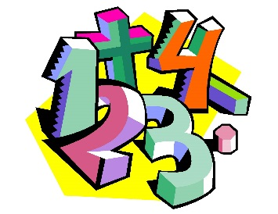 | Autumn 2 Year five  Unit 1 – Addition, Subtraction,  Multiplication, Division  Unit 2 – Fractions | Autumn 2 Year 6  Unit 1 – Addition, subtraction, Multiplication, Division  Unit 2 – Fractions, Decimals and Percentages
Times Tables
Tames tables lessons take place once each week. We focus on filling any gaps children may have through a variety of fun and engaging activities.
SCIENCE | Evolution and Inheritance  - Inheritance  - Adaptation  - Theory of Evolution  - Evidence of Evolution  - Human Evolution  - Adaptation analysis
OTHER TOPICS | History – This half term we are investigating fosils and dinosaurs. We will be exploring what fossils are and how they are formed. Our dinosaurs work will focus around when they were on earth and theories over their extinction.  Music - with Beth from Trafford Music Service on Friday.  PE – Agility Balance and Co-ordination on a Thursday with Mr Ritchie, Play to Learn with Mr Roberts on a Friday  RE – Judaism and Christianity
SPECIAL EVENTS/HOLIDAYS   | Please keep up-to-date with letters and our web page where you find all our special events oraganised!  - Please refer to our school calender 2022-2023 reminders to follow as and when they occur.
HOMEWORK PRIORITIES   | There is no official homework that is set by class but please make sure to work with your child on:  - Maths: Practice times tables. All children have Times Table Rockstars logins and set times tables.  - English: Work on spellings from their reading books.  - Reading: Please read the book you take home every evening

INDIVIDUAL BEHAVIOUR TARGETS
Please refer to your child’s IBP and get in touch with the class teacher if you have any concerns.
....................................................................................................................................................

