
Longford Park Overview History and Geography
Year B | Autumn 1 | Autumn 2 | Spring 1 | Spring 2 | Summer 1 | Summer 2
EYFS | Family & People  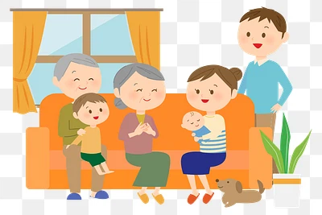 | Toys and Play  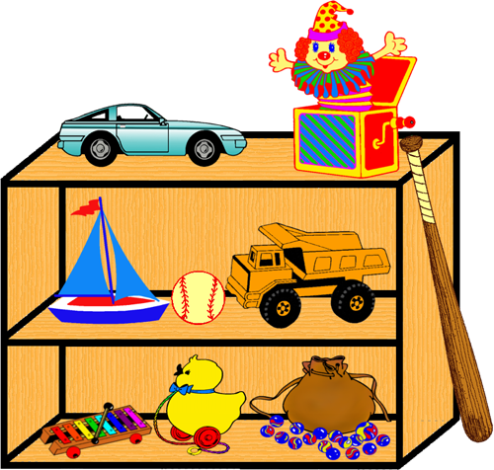 | Transport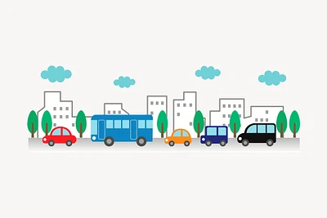 | Home and Lighting  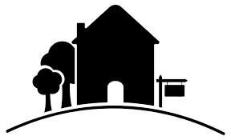 | School Days  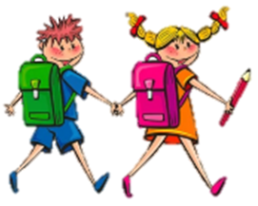 | Seaside Holiday  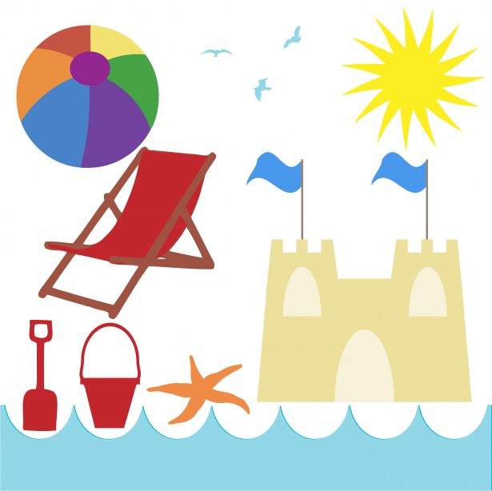
Year 1 / Year 2 | The Great Fire of London: How did the fire start?  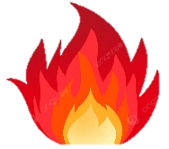 | Local Area:  Where do we live?   | Explorers and Adventurers:  What is an explorer?  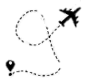 | Cold Places:  What is it like at the North and South Poles?  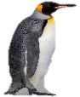 | Explore the life of a local artist: Who was LS Lowry?  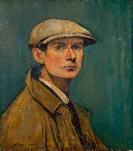 | Africa: What is it like to live in Tanzania?  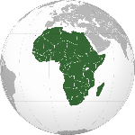
Year 3 / Year 4 | Ancient Greek Civilisation: what is its most significant legacy?  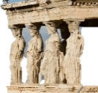 | Land Use: how diverse are local and UK landscapes?  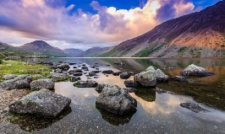 | The Romans: what impact did the Romans have on Britain?  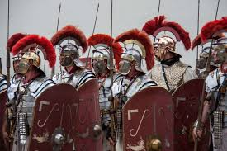 | Mountains and Volcanoes: what, where and why?  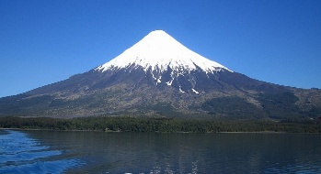 | Iron Age Britain: what have historians learnt about Iron Age Britain?  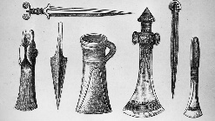 | The Water Cycle: why is it important?  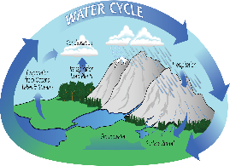
Year 5 / Year 6 | Victorians  Who were the Victorians?  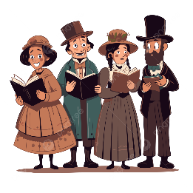 | South America:  Why does the Amazon matter?  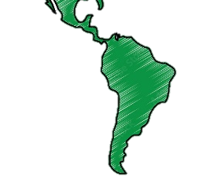 | The Maya: What made the Maya so distinctive?  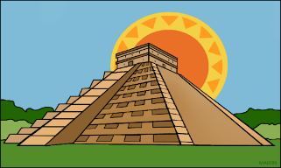 | Amazon River | Year 6 SATS  Significant turning points: how did experiences differ during WWII?  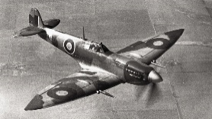 | Local and Global:  Why are trees and forests important?  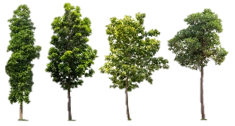

Longford Park Overview History and Geography
Year A | Autumn 1 | Autumn 2 | Spring 1 | Spring 2 | Summer 1 | Summer 2
EYFS | Family & People | Toys and Play | Transport | Home and Lighting | School Days | Seaside Holiday
Year 1 / Year 2 | Queen Victoria: how did Britain change during her lifetime?  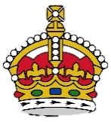 | Local to Global: how can we identify special places?  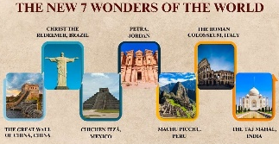 | Travel and Transport: how does travel and transport compare in the past, present and future?  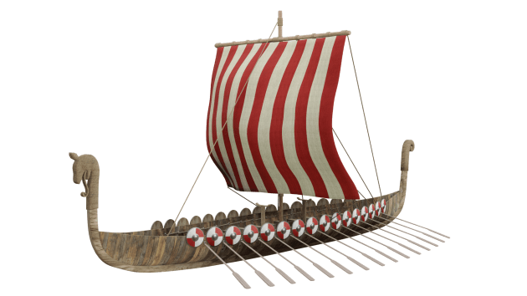 | Continents and Oceans: what can we find out about the world?  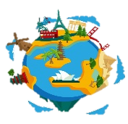 | Photographs from history: what can they tell us about Britain's recent past?   | Hot places: where are they and what are they like?  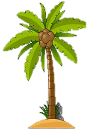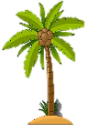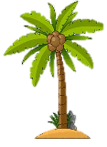
Year 3 / Year 4 | Stone Age Britain: what do archaeologists think they know about it?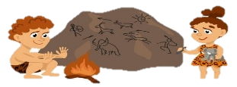 | Climate Zones: what are they and why do they matter?  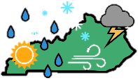 | Bronze and Iron Age Britain: how did life change during this time?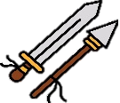 | The UK: who are we?  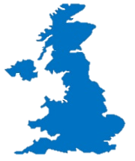 | Ancient Egypt: what stayed the same across 3,000 years?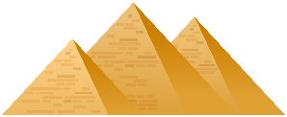 | Europe: what is it like to live in northern Italy?  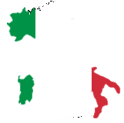
Year 5 / Year 6 | The Great War: how did the Great War affect local people and their communities?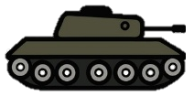 | Natural resources: what are they, where are they found, why are they important?  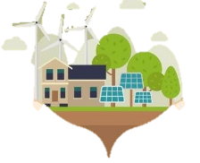  / North and South America: How diverse are their places and Landscapes?  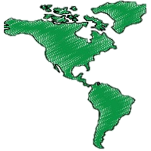 | The Vikings: why did they come to the British Isles?  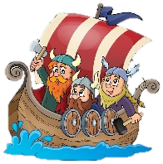 | Sustainable World: does it matter how we live?  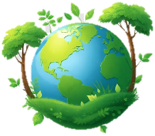 | Year 6 SATS  Early Islamic civilisation: how did Baghdad become the 'City of Peace'? | Time Zones: can we time travel on planet Earth?  

