
Class Plan
Class: Tan Term: Autumn 2 2022
SUBJECT | LEARNING
LITERACY  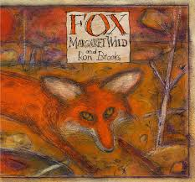   | This term we will be continuing to work on our text ‘Fox’. We are writing instructions, an alternative ending and a letter to one of the characters.  We will then move onto a non-fiction text - Cool Architecture. We will look at the features of a non-chronological report and write on of our own. We will look at some grammatical features including pronouns, conjunctions and clauses and we will be looking at lots of unusual buildings!
MATHS  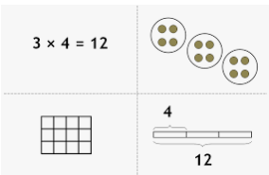 | We will start off the half term by looking at Multiplication and Division. Along with lots of times tables practice, we will also be looking at different ways to multiply and divide and will continue to use different models and images to support us.  This will build on the Place Value and Addition and Subtraction we did last half term.  We will then move on to Fractions. We will consider what a fraction is and what the different parts of a fraction represent as well as representing fractions in different ways.
SCIENCE   | Properties and Changes of Materials  We will compare and group together everyday materials based on evidence from comparative and fair tests. The children will understand that some materials will dissolve in liquid to form a solution. They will use their knowledge of solids, liquids and gases to decide how mixtures might be separated, including through filtering, sieving and evaporating. The children will also give reasons, based on evidence from comparative and fair tests, for the particular uses of everyday materials, including metals, wood and plastic
HISTORY | 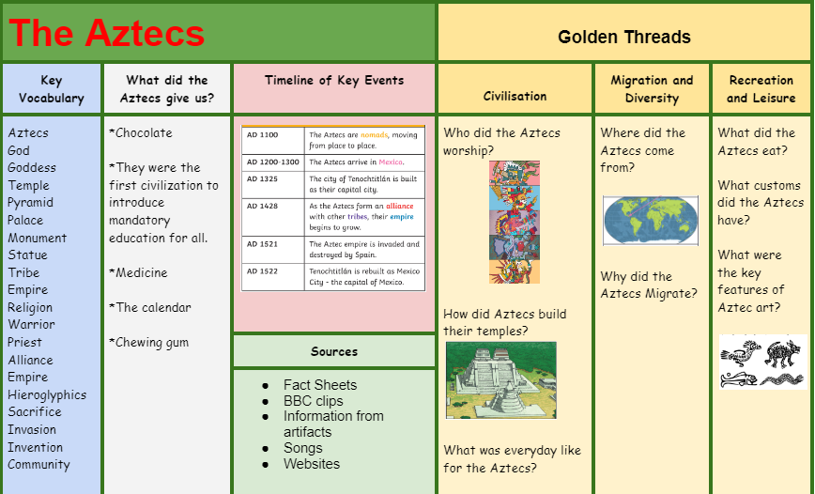  RE – What do religions say to us when life gets hard?  Music - Trafford Music Service on a Thursday.  Computing – Multimedia and technology in our lives  PE – taught by Mr Ritchie on a Wednesday – Please have PE kits in school.
SPECIAL EVENTS/HOLIDAYS  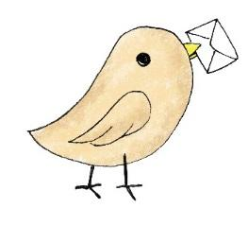 | Please keep up-to-date with letters and our web page where you find all our special events organised!  - Please refer to our school calendar 2022-2023 – reminders to follow as and when they occur.
READING   | We read every day in school.  Your child will taking a reading book home to read with an adult. Please try and read a few pages with your child and record it in their reading record.

