 | Autumn | Spring | Summer
EYFS | What Can We See?  Finding circles  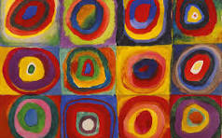  Artists: Wassily Kandinsky | How Can We Explore Colour? Explorer’s Books: Collecting Colour  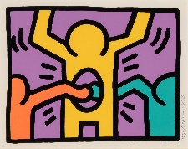  Artist: Keith Haring | How Can We Build Worlds? World in a Matchbox  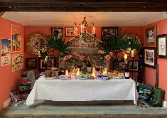  Artists: Petros Chrisostomou; Laura Woodroff
Year 1 & 2 | Inspired by Flora & Fauna | Expressive Painting | Access Art: Stick transformation project  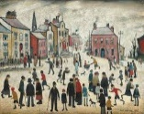  Artists: L.S.Lowry, Chris Kenny  Outcomes: Stick man sculpture
Year 3 & 4 | Festival Feasts  Medium:  Paper/Card, Drawing Materials, Modelling Materials (incl. Modroc)  Artists: Claes Oldenberg, Lucia Hierro, Nicole Dyer | Making Animated Drawings  Medium:  Paper, (Digital media)  Artists: Lauren Child, Steve Kirby, Andrew Fox, Lucinda Schreiber | Exploring PatternMedium:  Paper, Pens, Paint  Artists:  Rachel Parker, Shaheen Ahmed, Andy Gilmore, Louise Despont
Year 5 & 6 | Fashion Design - Medium:  Paper, Acrylic Paint, Tape  Artists: Alice Fox, Rahul Mishra, Pyer Moss, Tatyana Antoun, Hormazd Narielwalla | Typography and Maps- Themes:  Identity, Environment, Habitat  Medium:  Pencil, Pen, Paper  Artists: Louise Fili, Grayson Perry, Paula Scher, Chris Kenny | Exploring Identity - Medium:  Drawing Materials, Tablet (if digital), Paper  Artists: Njideka Akunyili Crosby, Yinka Shonibare, Thandiwe Muriu, Mike Barrett
https://www.pinterest.co.uk/user_odllnjeyn/

