 | Autumn | Spring | Summer
EYFS | What Can We See?  Finding circles  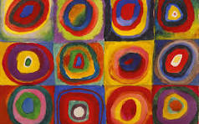  Artists: Wassily Kandinsky | How Can We Explore Colour? Explorer’s Books: Collecting Colour  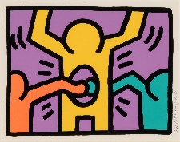  Artist: Keith Haring | How Can We Build Worlds? World in a Matchbox  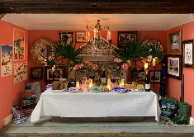  Artists: Petros Chrisostomou; Laura Woodroff
Year 1 & 2 | Be an architect  Outcome: byuikd a house from Pudding Lane | Access Art: Exploring the World through Mono Print  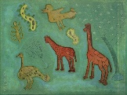  Artists: Xgaoc’o X’are, Leonardo Di Vinci  Outcome: Mono print  Curriculum link: Science - Animals including humans/Living things and their habitats | Access Art: Explore and draw  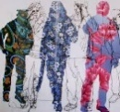  Artists: Rosie James, Alice Fox  Outcome: Wax resist leaves and plants  Curriculum link: Plants
Year 3 & 4 | Access Art: Gestural Drawings in charcoal  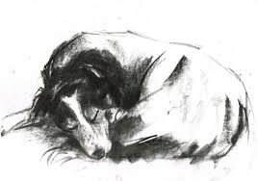  Artists: Heather Hansen, Laura McKendry, Edgar Degas  Outcome: Cave-style drawing on a textured ‘wall’ | Access Art: Telling stories through drawing and making  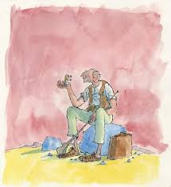  Artists: Rosie Hurley, Inbal Leitner, Roald Dahl, Quentin Blake  Outcome: Make a sculptural character from a fantasy story | Access Art: Cloth, Thread, Paint  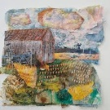  Artists: Alice Kettle, Hannah Rae  Outcome: Ancient Egyptian landscape
Year 5 & 6 | Access Art: Using Art To Explore Global Issues  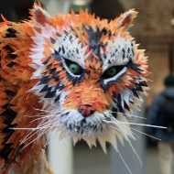  Artist: Faith Bebbington, Frances Hatch, NOMINT  Outcome: Modroc polar bear | Access Art: Shadow Puppets  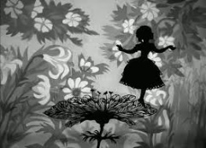  Artists: Lotte Reiniger, Matisse, Wayang Shadow Puppets, Phillipp Otto Runge, Pippa Dyrlaga, Thomas Witte  Outcome: Create shadow puppets linked to myth work | Access Art: Mixed Media Land and Cityscapes  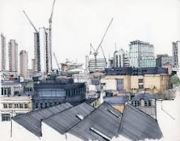  Artists: Vanessa Gardiner, Shoreditch Sketcher, Kittie Jones  Outcome: make drawings/paintings at different scales and ratios based on New York
https://www.pinterest.co.uk/user_odllnjeyn/

