
Class Plans
Class: Wilson/ Shafai Term: Autumn 2 2022
SUBJECT | LEARNING
LITERACY   | The Blue house: This term our focus book will be focusing on the Blue house by Phoebe Wahl. Her book is about a young boy living with his dad coping with change  We will also be concentrating on our punctuation and grammar and making our work very interesting by using lots of adjectives, nouns, verbs and adverbs.
MATHEMATICS  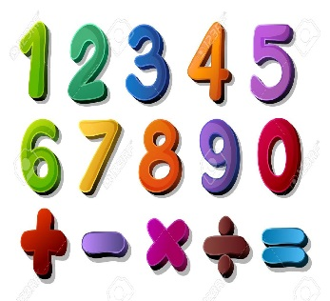 | Autumn two  Multiplication and Division: we have been doing our times tables once a week in class so we will be focusing on how to divide  Fractions: we will be looking at what fractions are and working on our fractions up to and including twelfths | Alongside our topics in Maths, we will also be focusing on our times tables once a week so that we can start to become fluent in them.
SCIENCE   | Autumn one  Animals including humans : We will be learning about different kinds of animals (including humans) and their life processes. We will be learning lots of scientific language such as what herbivore and carnivore means | We will think about our topic and come up with enquiry questions and find out the answers to our questions!
OTHER TOPICS    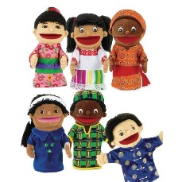 | History: The Anglo Saxons: we will be looking at who the Anglo Saxons were and how they changed Britain  DT: This term we will be focussing on puppets. We will be looking at how to stich our puppets and designing our own puppets  RE – We are looking at why and how Jesus inspires people even today  French- Every Tuesday with our teacher who comes from France  Music - with Beth from Trafford Music Service on Thursday.  PE – with Mr Ritchie on Friday .
SPECIAL EVENTS/HOLIDAYS   | Please keep up-to-date with letters and our web page where you find all our special events organised!  - Please refer to our school calendar 2022-2023 – reminders to follow as and when they occur.
READING   | We read every day in school and if possible, we would like you to read with your child each night.

INDIVIDUAL BEHAVIOUR TARGETS
Please refer to your child’s IBP and get in touch with the class teacher if you have any concerns.
...................................................................................................................................................

